National Park Travel Guide

# Death Valley National Park

## Description

In this below-sea-level basin, steady drought and record summer heat make Death Valley a land of extremes. Yet, each extreme has a striking contrast. Towering peaks are frosted with winter snow. Rare rainstorms bring vast fields of wildflowers. Lush oases harbor tiny fish and refuge for wildlife and humans. Despite its morbid name, a great diversity of life survives in Death Valley.

## Weather

SPRING is the most popular time to visit Death Valley. Warm and sunny days with the possibility of spring wildflowers is a big attraction. SUMMER starts early in Death Valley. By May the valley can be scorching hot. AUTUMN arrives in late October, with warm but pleasant temperatures and generally clear skies. WINTER has cool days, chilly nights and rarely, rainstorms. With snow capping the high peaks and low angled winter light, this season is especially beautiful for exploring the valley.

## Activities

* Bookstore and Park Store
* Camping
* Canyoneering
* Guided Tours
* Hiking
* Living History
* Mountain Biking

## Images

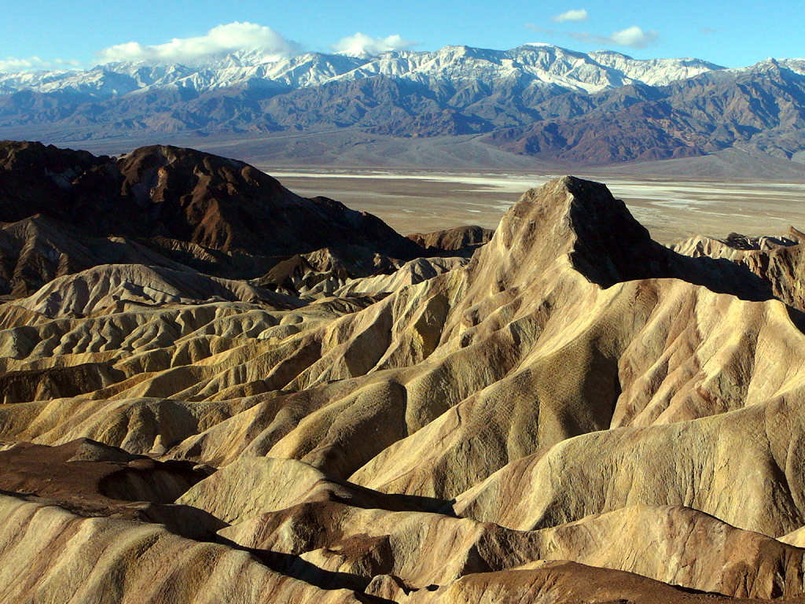

Zabriskie Point is a popular place to view sunrise over the badlands. Credit: NPS Photo

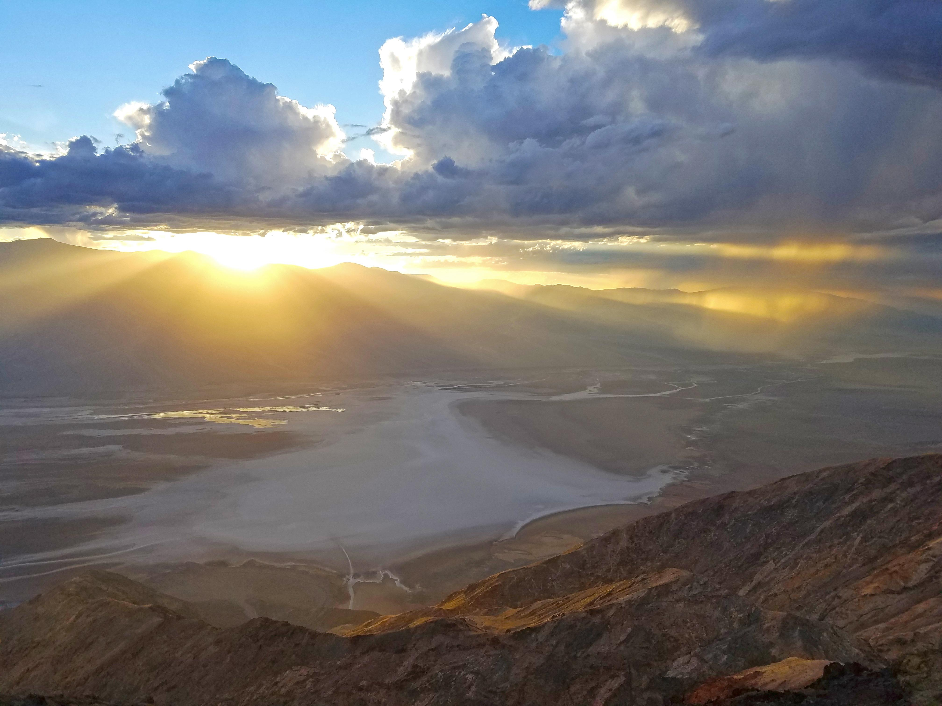

A mile above the salt flats in the valley below, Dantes View provides breathtaking vistas. Credit: NPS / Jan Vanderlay

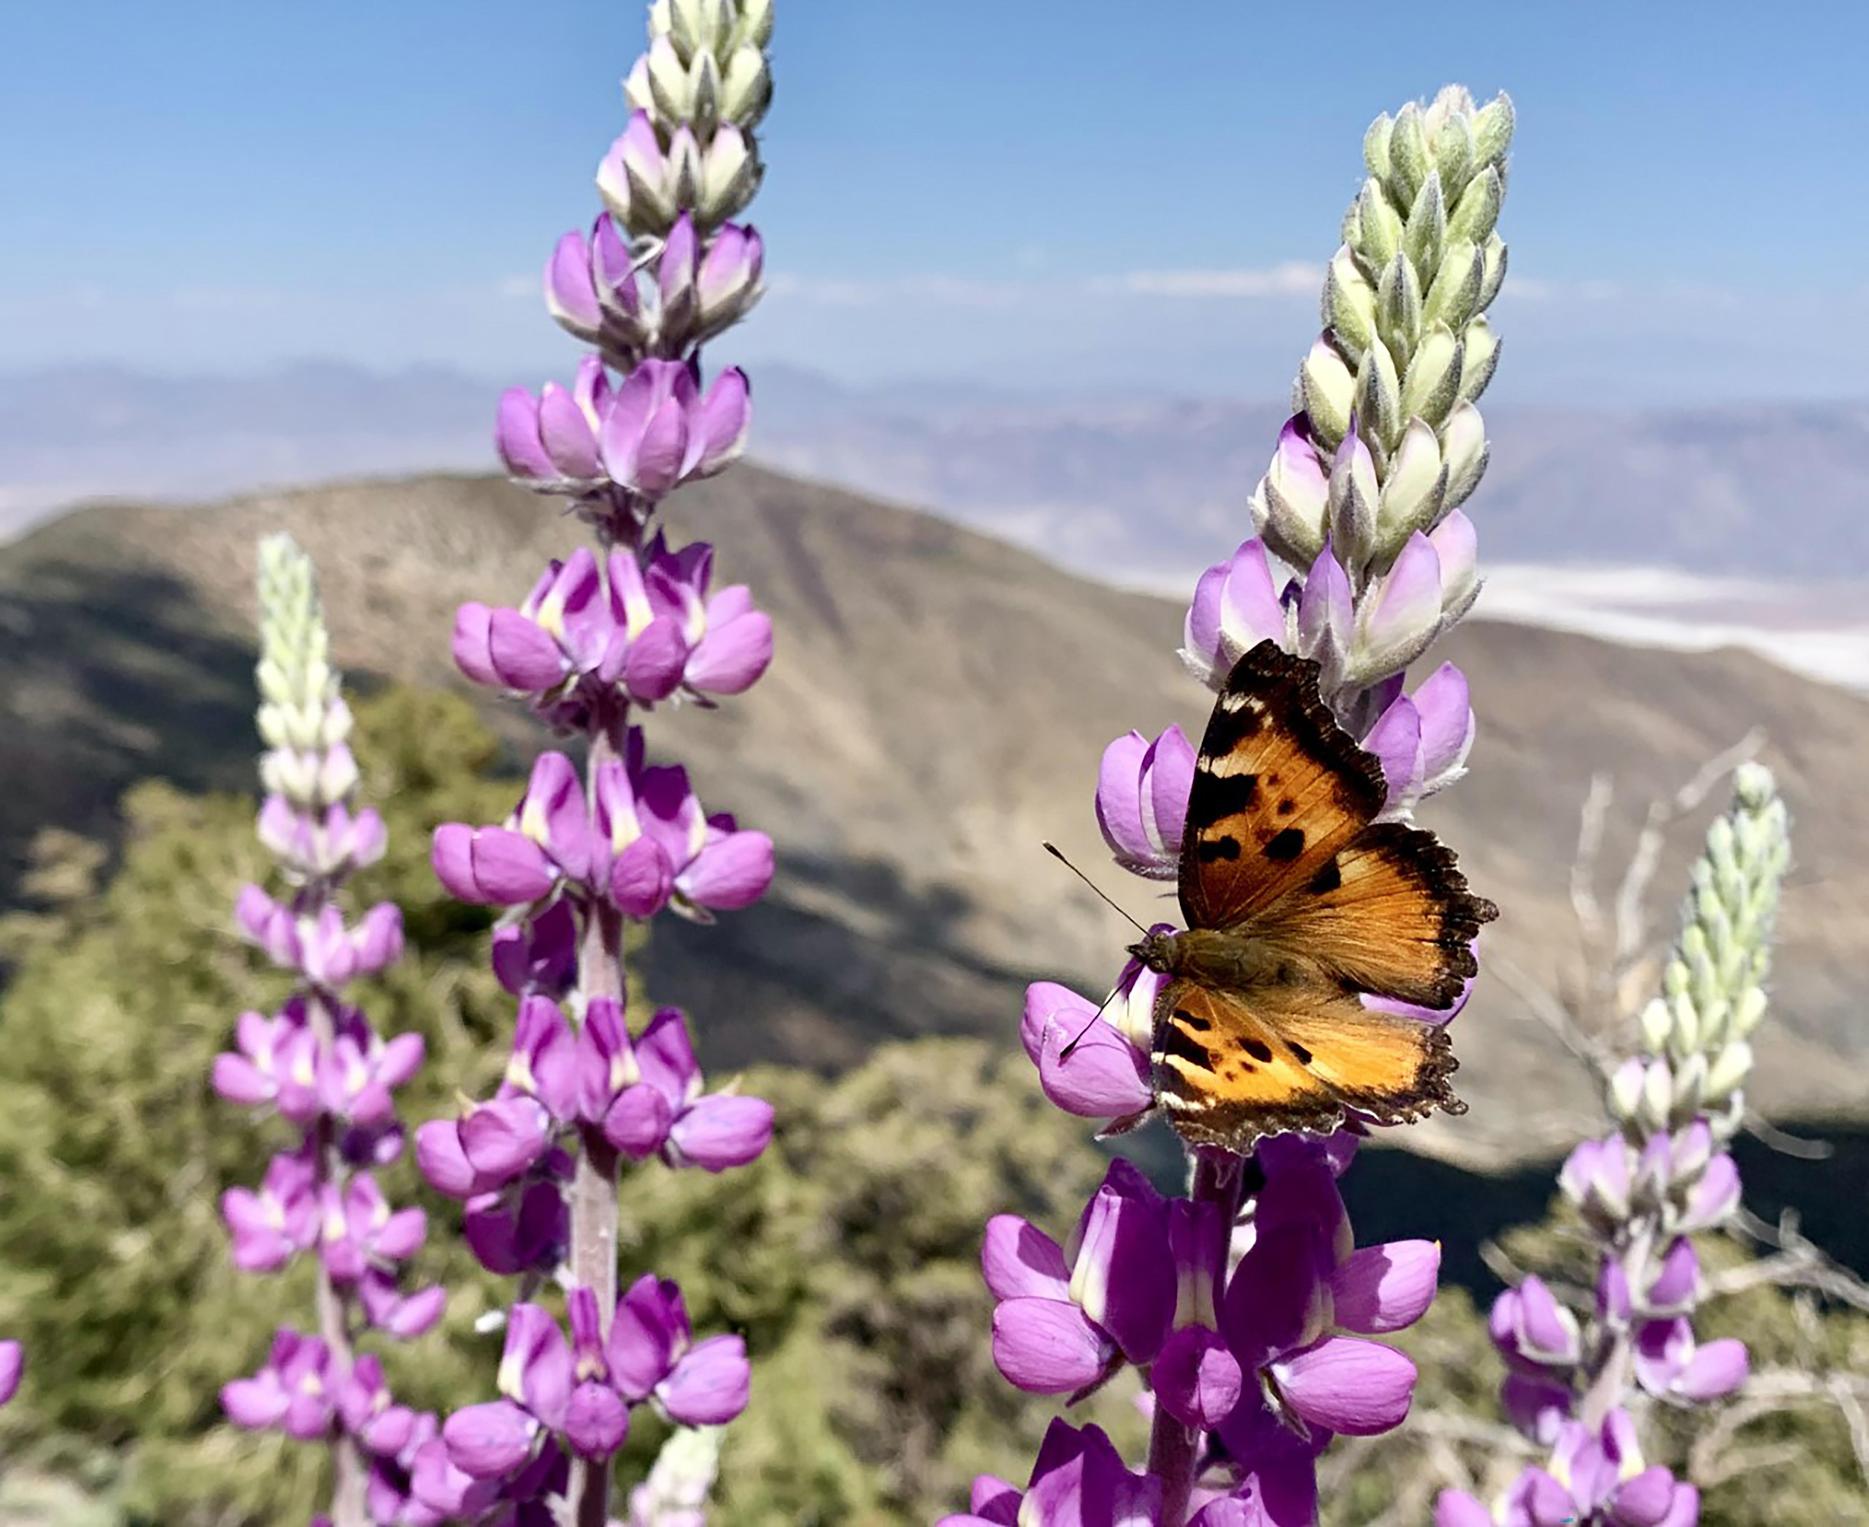

Higher elevations provide a respite from the heat in this alpine ecosystem. Credit: NPS / J. Jurado

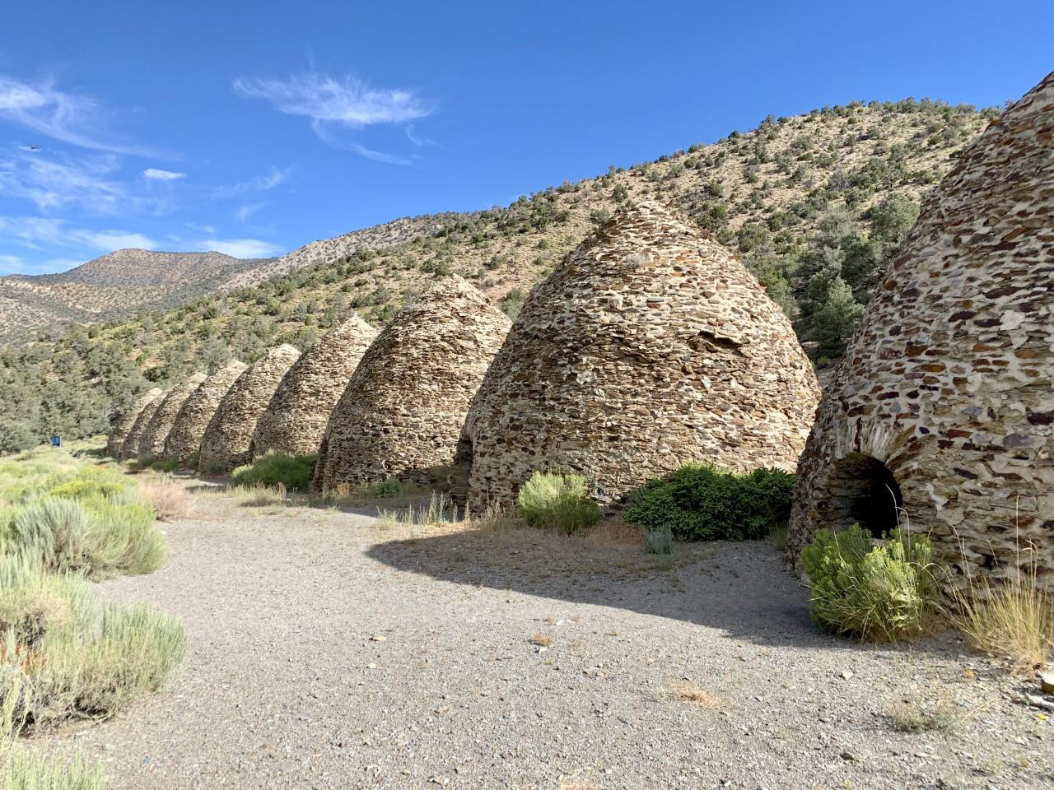

Nearly a century and a half old, these are some of the best preserved kilns in the western U.S. Credit: NPS / J. Jurado

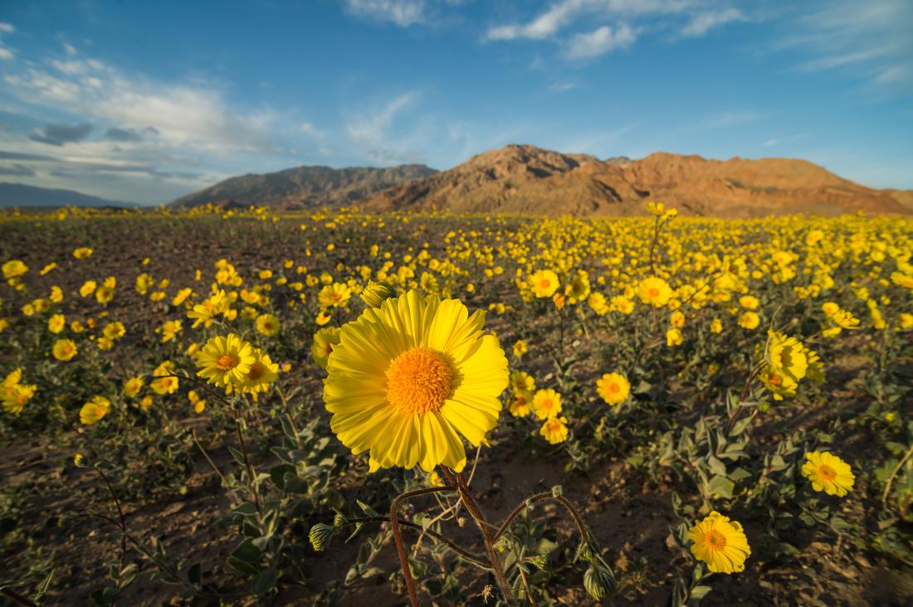

About once a decade, rains at the right times can lead to a rare superbloom! Credit: NPS / Kurt Moses

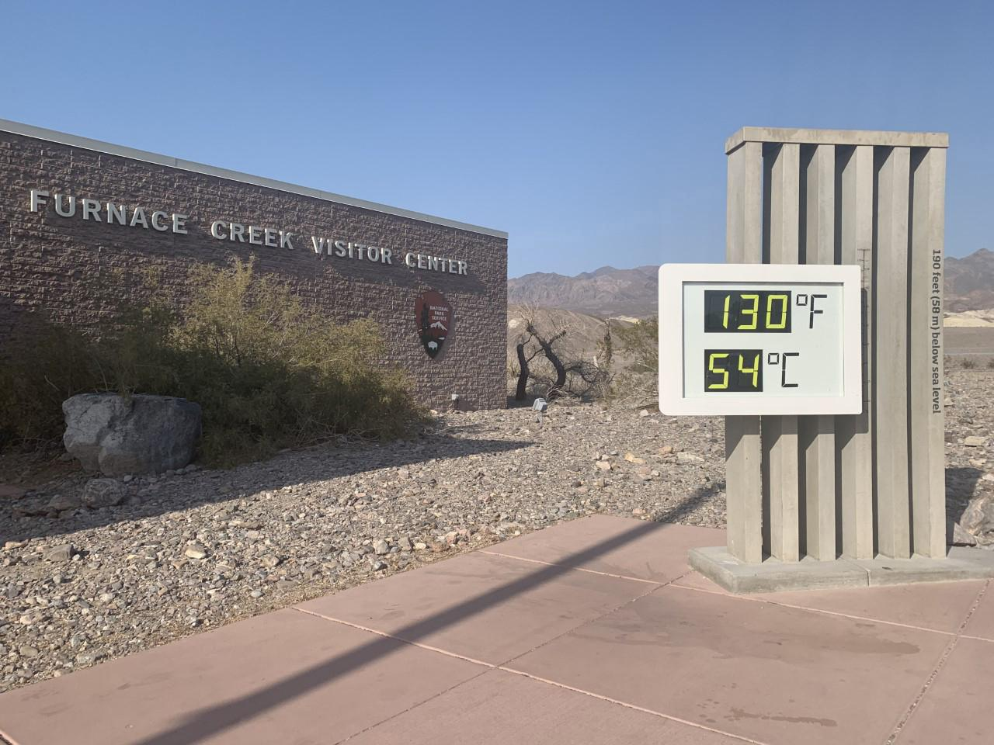

Summers are infamously hot, as for 6 months of the year temperatures above 120 degrees are regularly recorded. Credit: NPS / J. Jurado

## Operating Hours

The park is open daily all year.

## Contact Information

### Address

PO Box 579  
CA  
92328

### Website

https://www.nps.gov/deva/index.htm

# Great Basin National Park

## Description

From the 13,063-foot summit of Wheeler Peak, to the sage-covered foothills, Great Basin National Park is a place to sample the stunning diversity of the larger Great Basin region. Come and partake of the solitude of the wilderness, walk among ancient bristlecone pines, bask in the darkest of night skies, and explore mysterious subterranean passages. There's a whole lot more than just desert here!

## Weather

There is almost an 8,000 ft (2,400 m) difference in elevation between Wheeler Peak and the valley floor. Weather conditions in the park vary with elevation. In late spring and early summer, days in the valley may be hot, yet the snow pack may not have melted in the higher elevations. The Great Basin is a desert, with low relative humidity and sharp drops in temperature at night. In the summer, fierce afternoon thunderstorms are common. It can snow any time of the year at high elevations.

## Activities

* Climbing
* Guided Tours
* Picnicking
* RV Camping
* Road Biking
* Shopping
* Skiing
* Stargazing

## Images

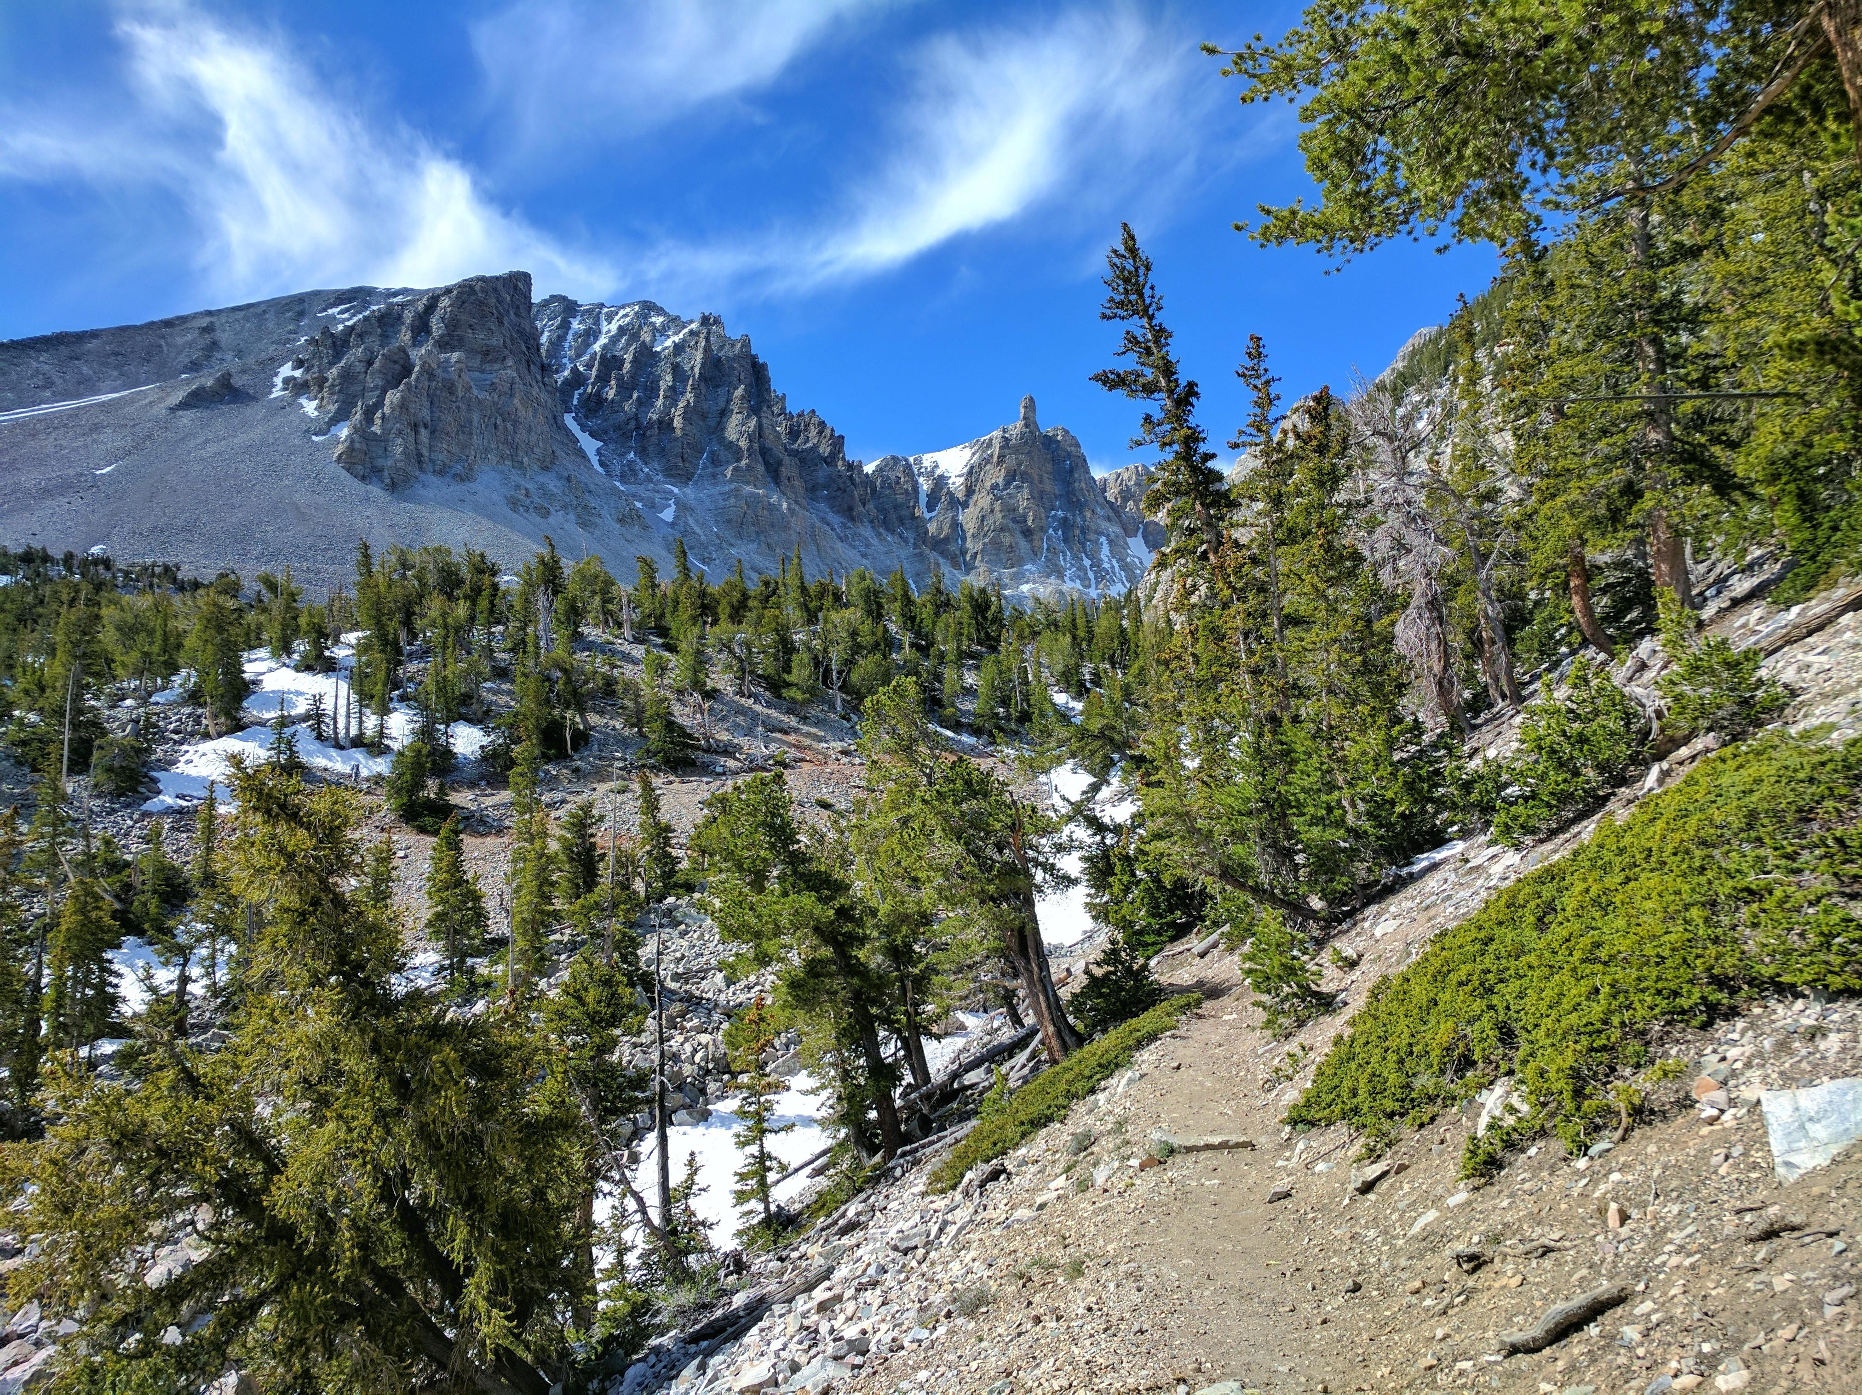

Trail to ancient bristlecone pine trees. Credit: NPS Photo

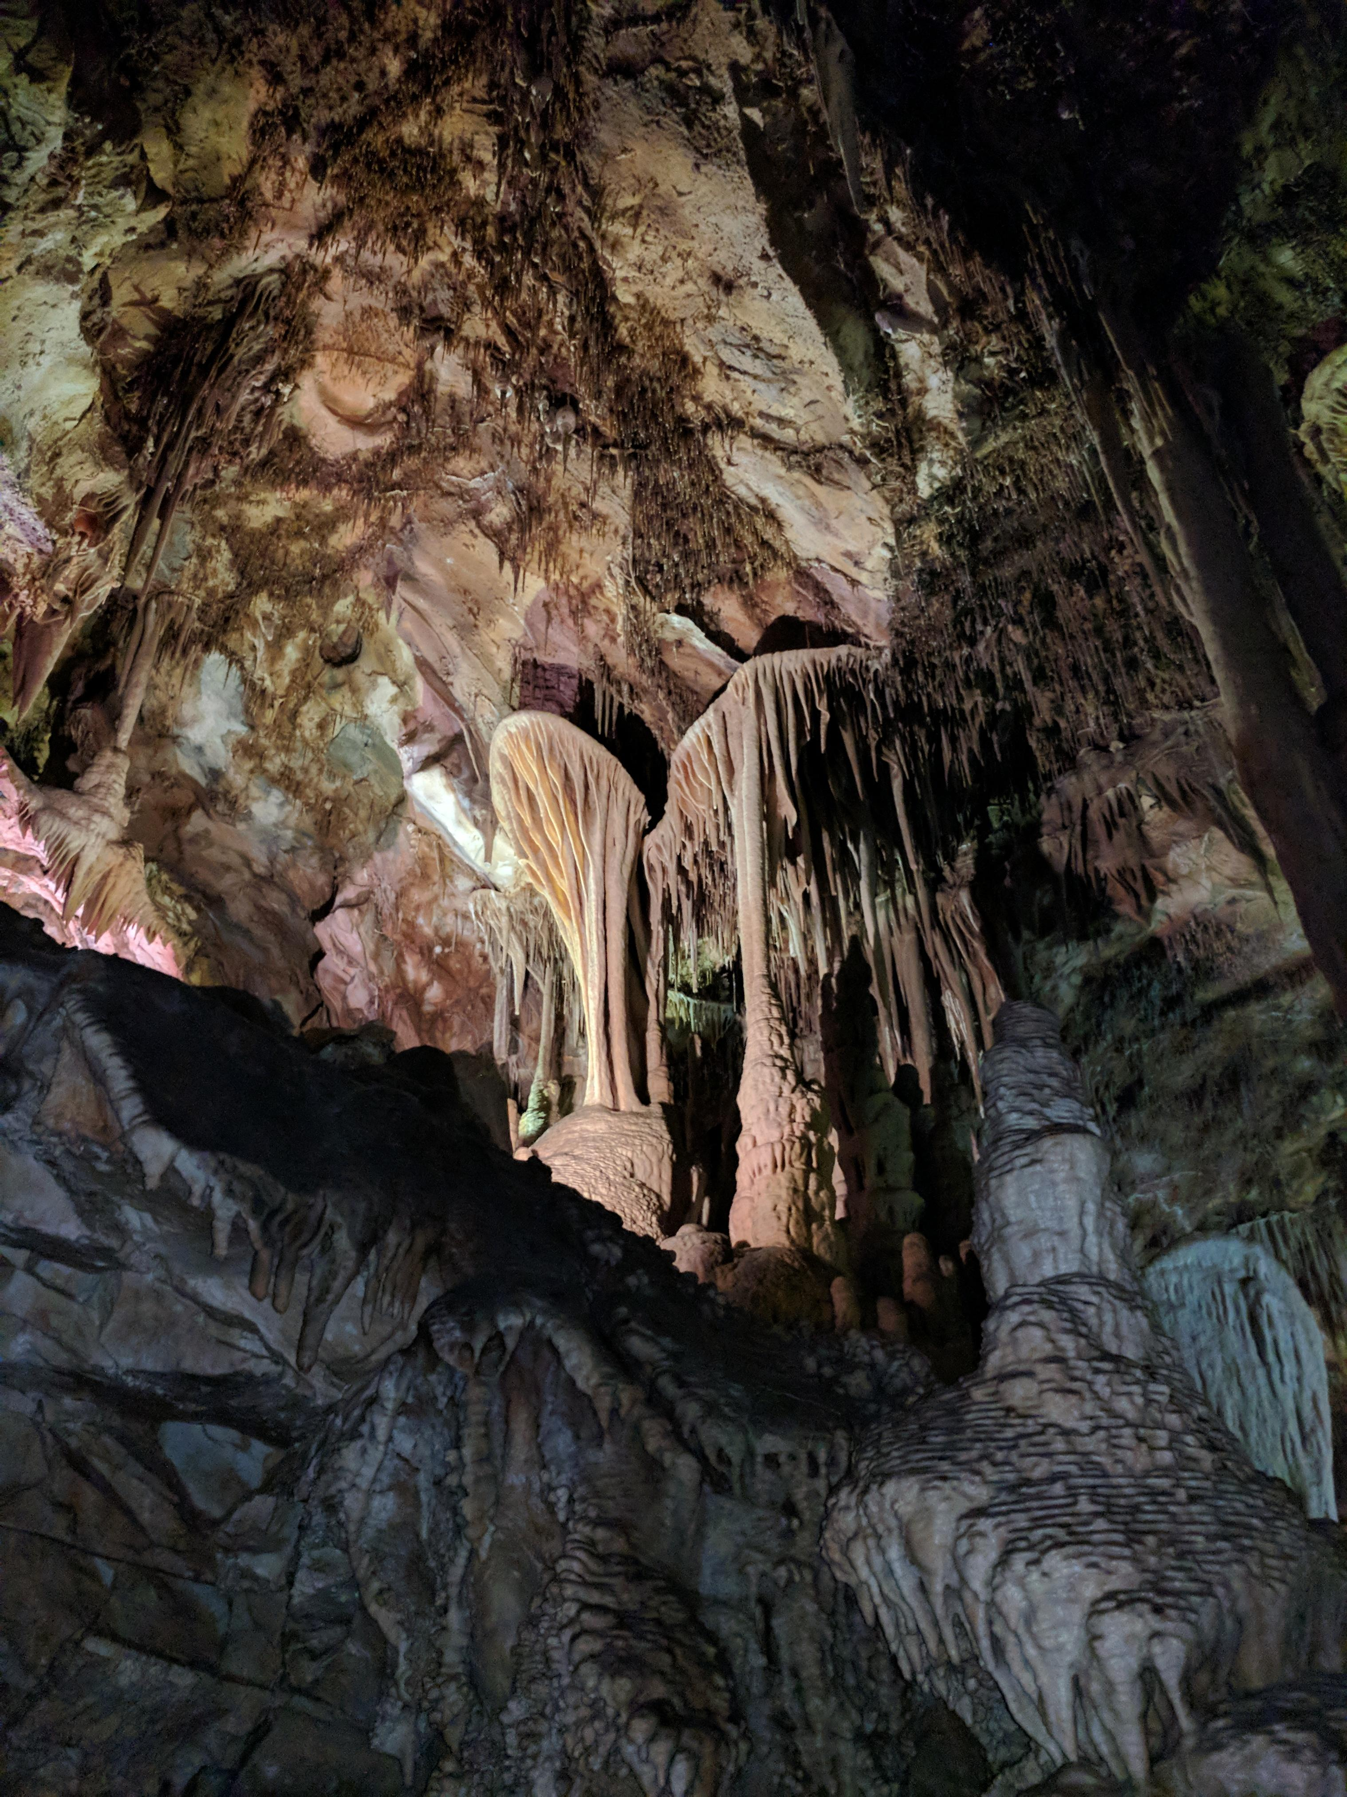

Lehman Caves of Great Basin National Park offers incredible views of a rare subterranean world. Credit: NPS Photo

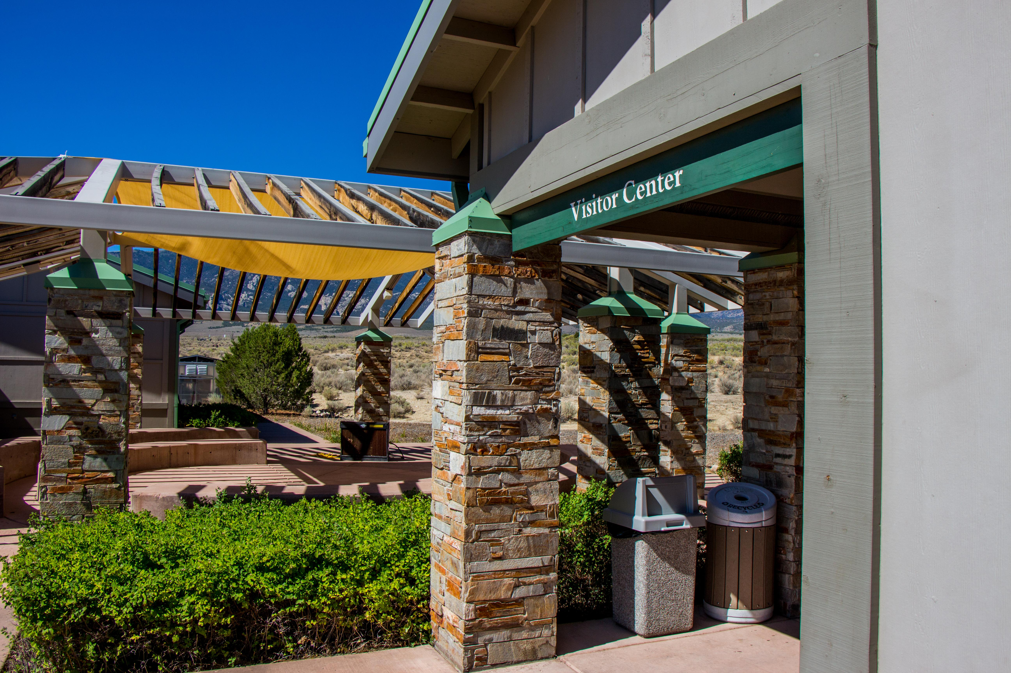

Great Basin Visitor Center just six miles from the park entrance Credit: NPS Photo

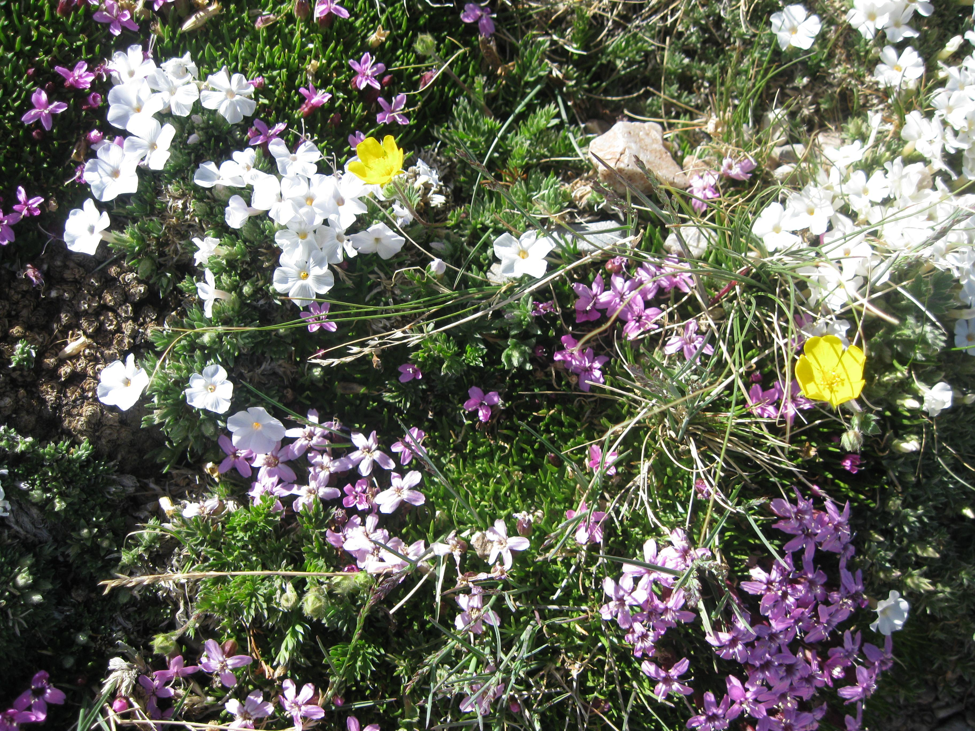

Flowers grow even at the high altitudes of the Great Basin National Park Credit: NPS Photo

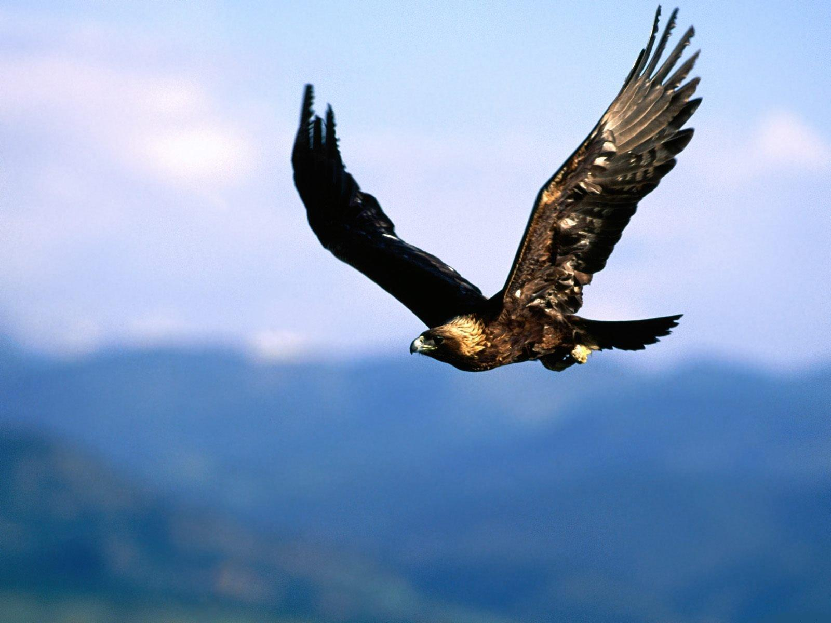

Wildlife is abundant at Great Basin National Park including birds, deer, fish, and mountain lion. Credit: NPS Photo

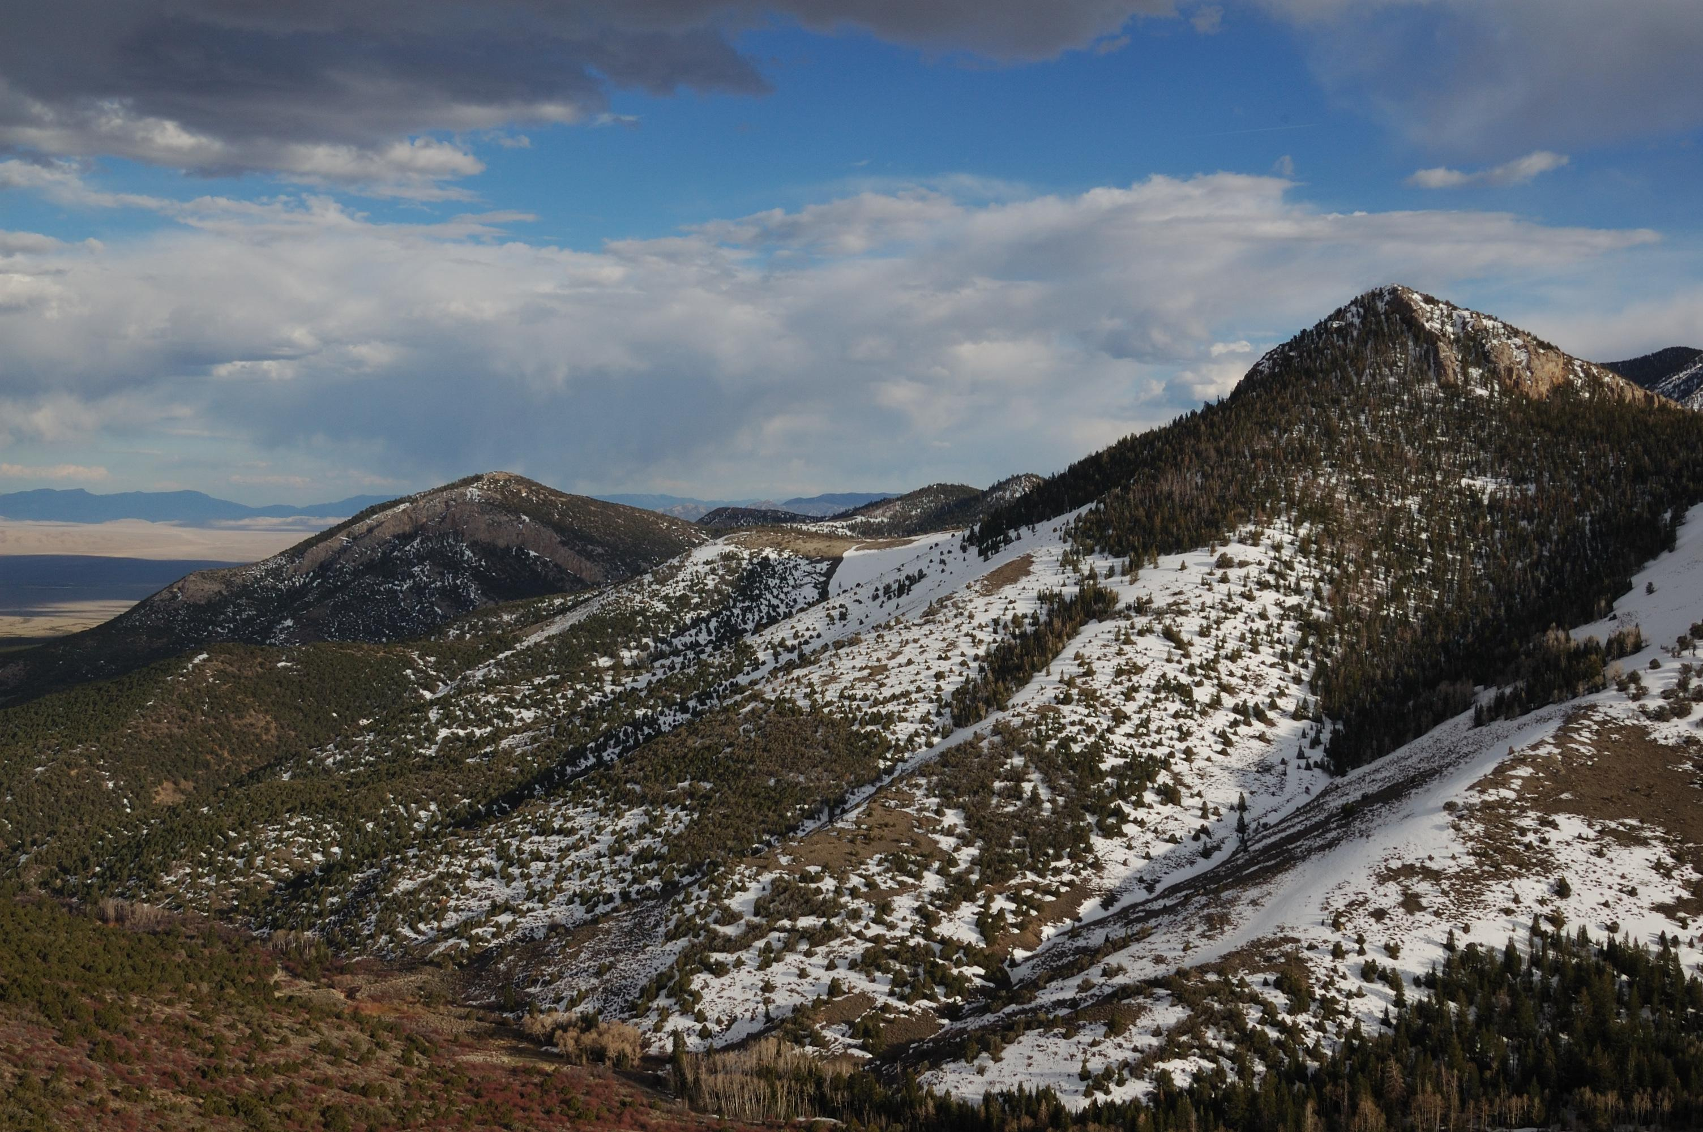

Snow can come early, even in the fall at Great Basin. Credit: NPS Photo

## Operating Hours

Park Grounds and Trails

## Contact Information

### Address

Lehman Caves Visitor Center  
Nevada 488  
NV  
89311

### Website

https://www.nps.gov/grba/index.htm

# Capitol Reef National Park

## Description

Located in south-central Utah in the heart of red rock country, Capitol Reef National Park is a hidden treasure filled with cliffs, canyons, domes, and bridges in the Waterpocket Fold, a geologic monocline (a wrinkle on the earth) extending almost 100 miles.

## Weather

Weather is posted daily; check at the park visitor center for weather updates. Do not enter into narrow canyons if there is a threat of rain or if rain has been falling in the area. Rain and snow may also make dirt roads impassable to vehicles.

## Activities

* Arts and Crafts
* Biking
* Canyoneering
* First Person Interpretation
* Hands-On
* Horse Camping (see also Horse/Stock Use)
* Horse Trekking
* Living History
* Park Film

## Images

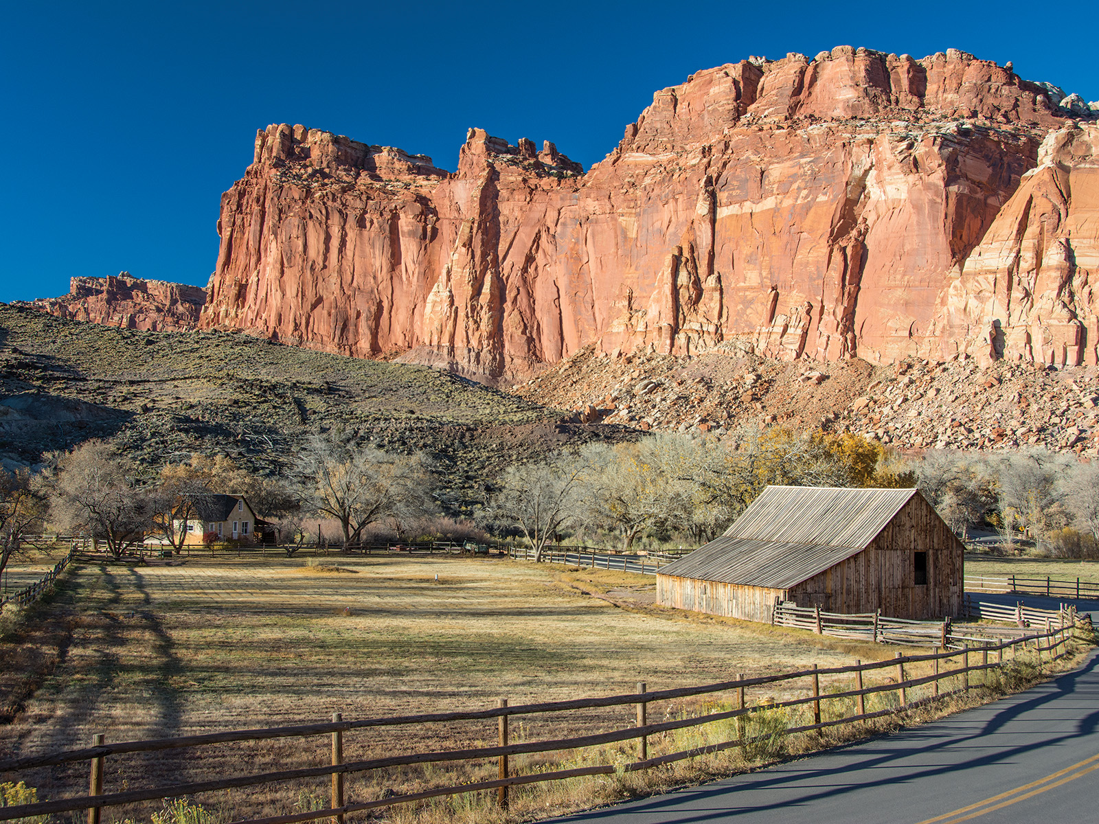

Windgate sandstone towers above historic Fruita farms and homes Credit: NPS Photo

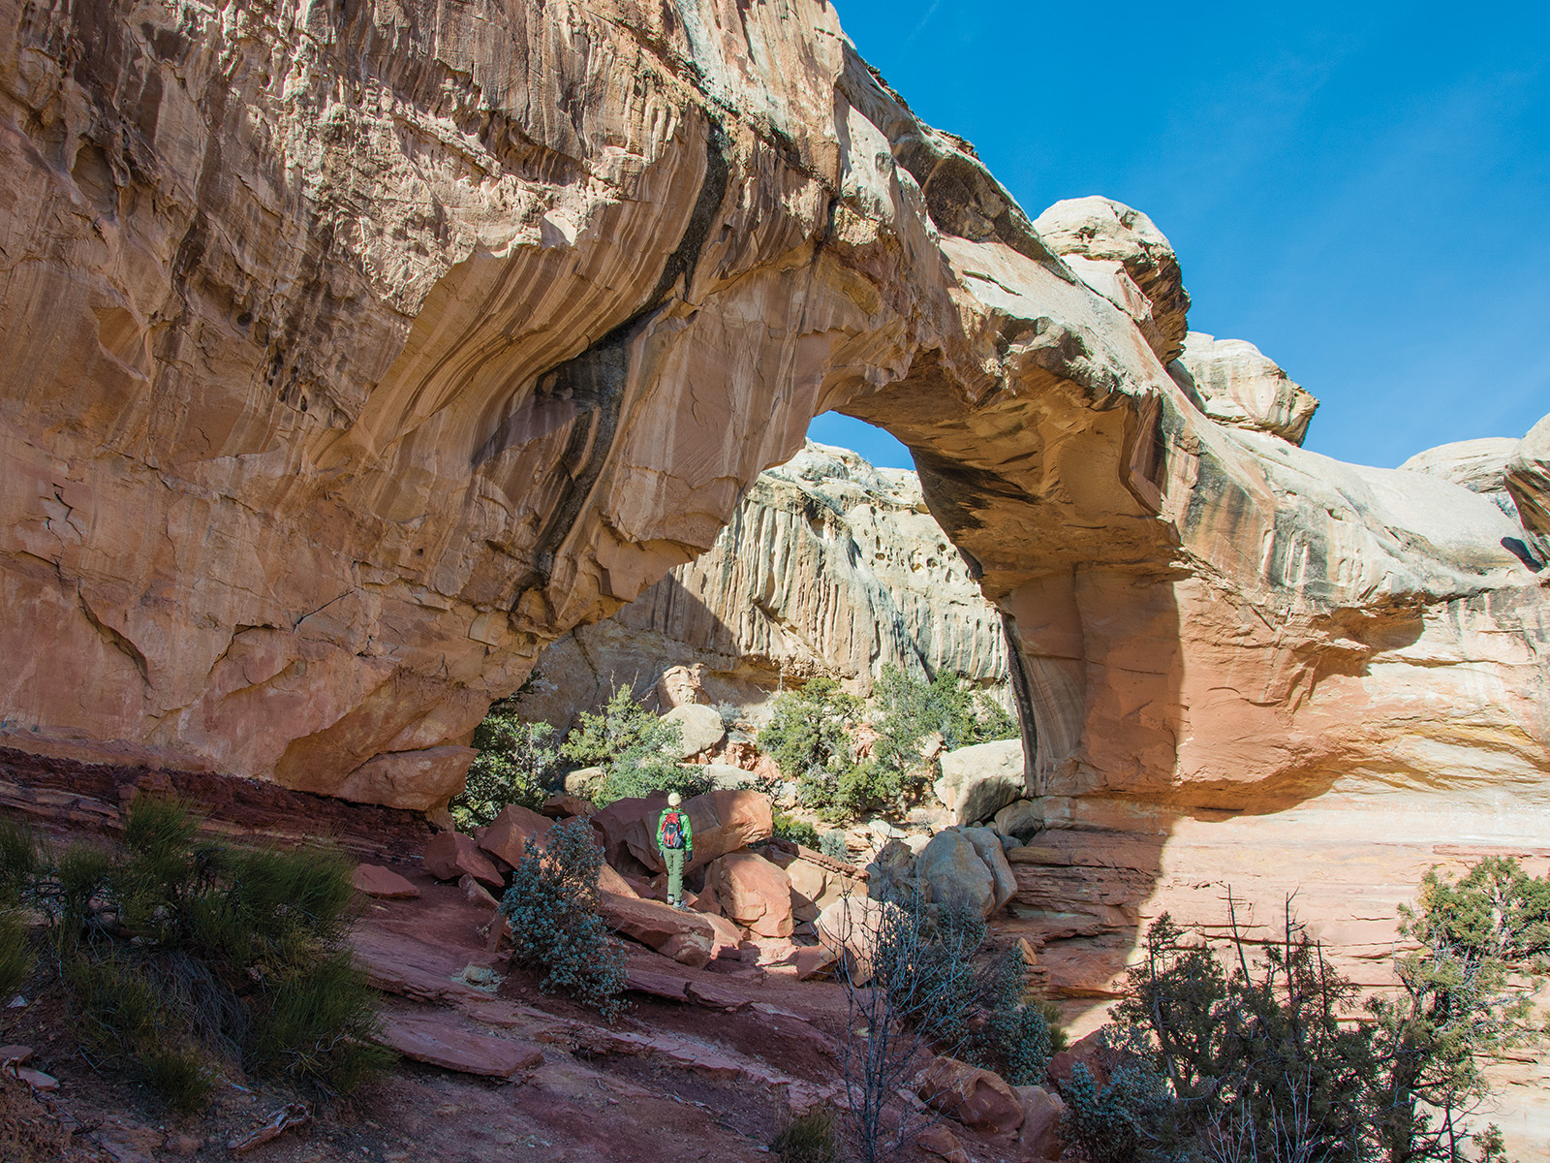

Hickman Bridge, a natural sandstone bridge, is a popular hike in the park. Credit: NPS Photo

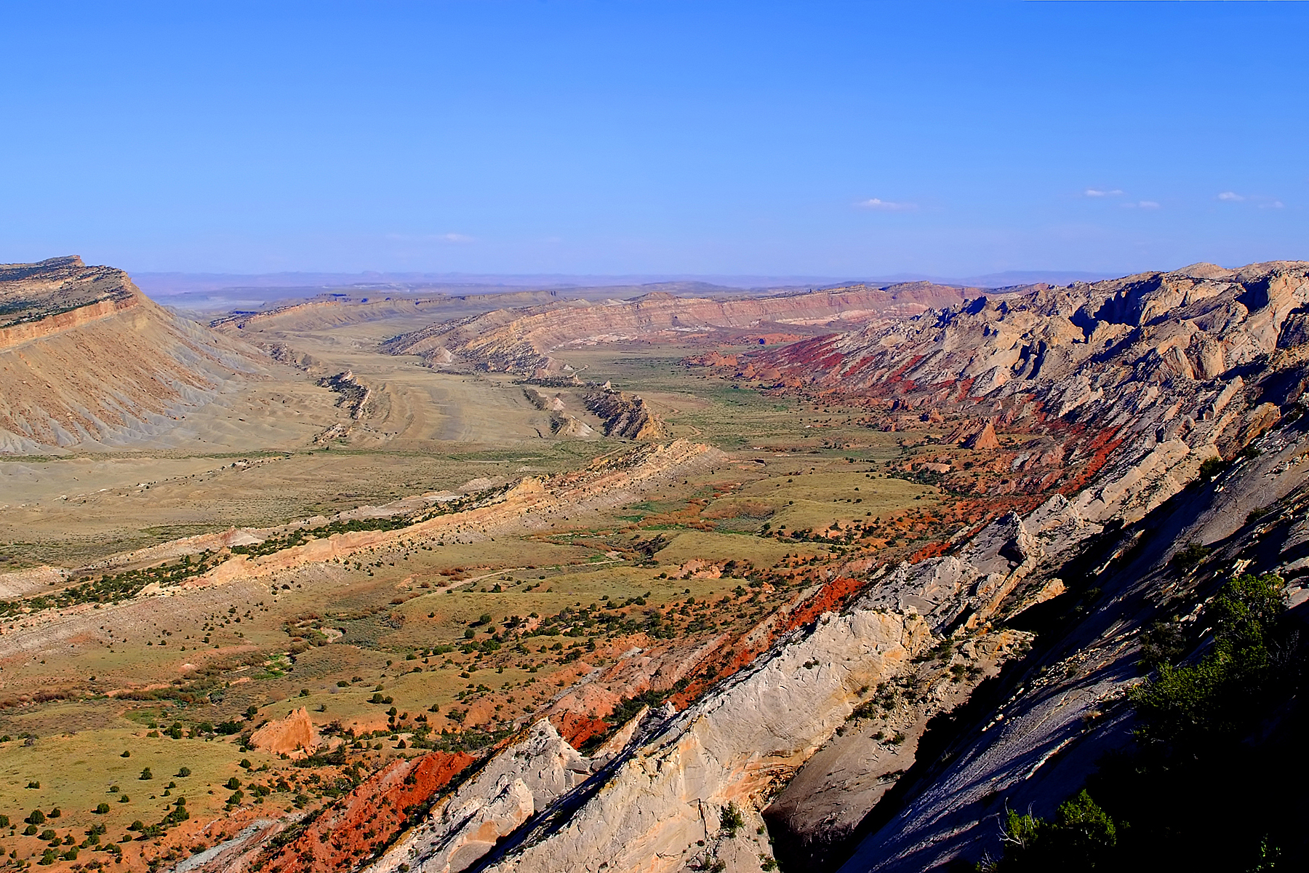

The Strike Valley shows colorful layers in the Waterpocket fold. Credit: NPS Photo

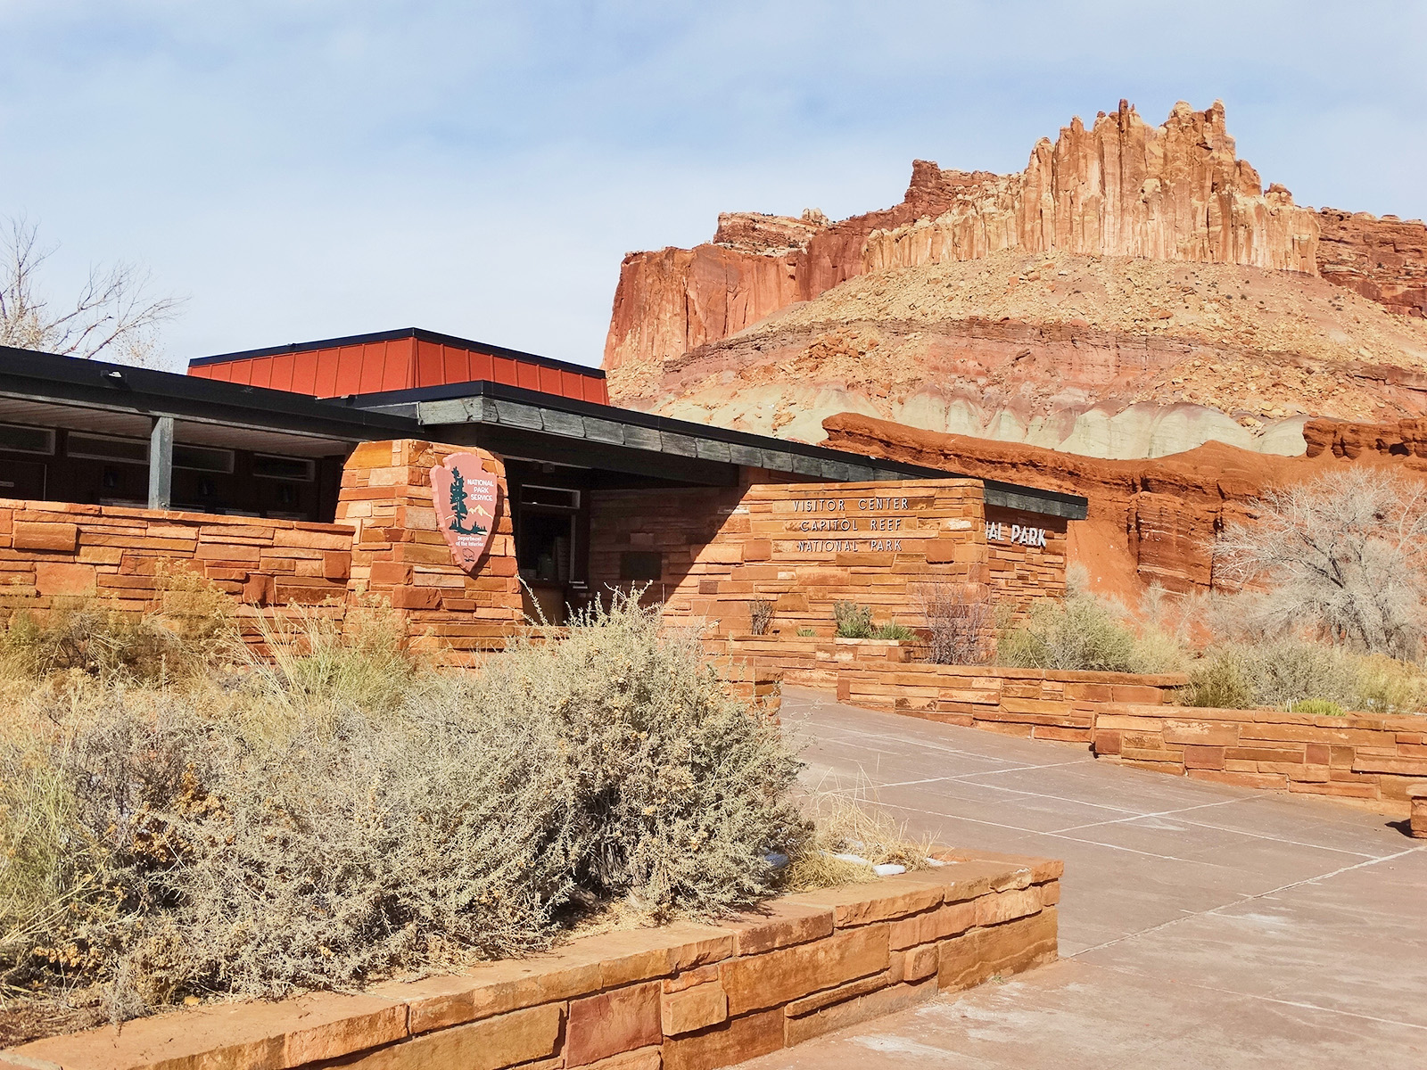

The Capitol Reef Visitor Center sits below cliffs known as "The Castle". Credit: NPS Photo

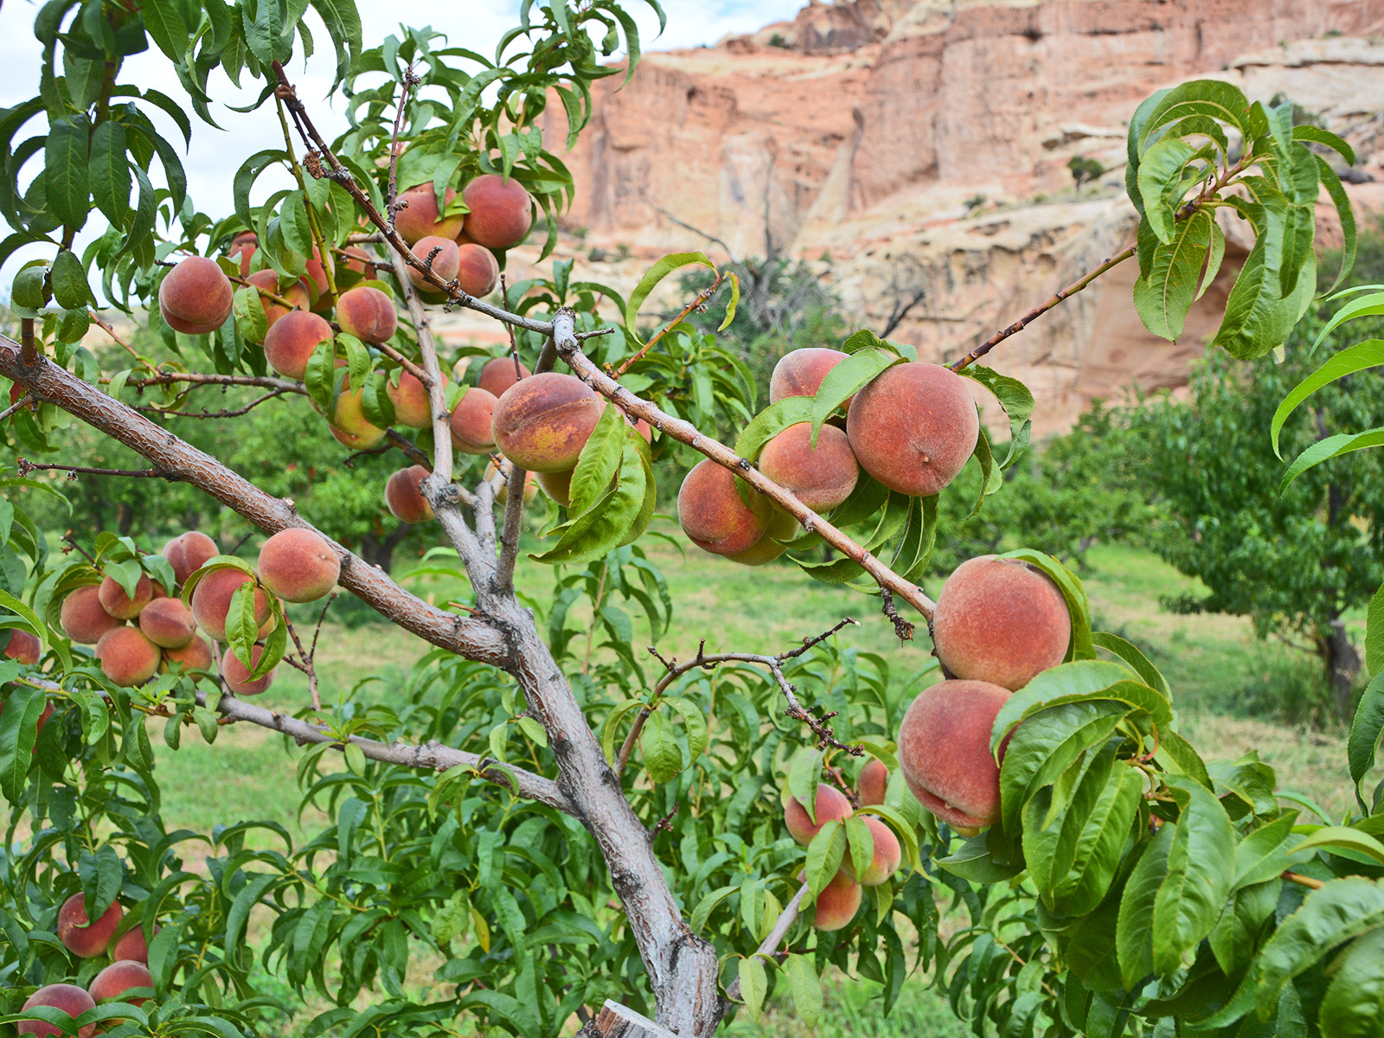

The Capitol Reef Orchards, planted in the pioneer era, remain a popular place for visitors today. Credit: NPS Photo

## Operating Hours

Capitol Reef is a 24 hour park, open all day, every day. The visitor center is open daily, except for some major holidays. Visitor center hours vary, call 435-425-3791 and follow the prompts for current visitor center information.

## Contact Information

### Address

52 West Headquarters Drive  
UT  
84775

### Website

https://www.nps.gov/care/index.htm

# Kobuk Valley National Park

## Description

Caribou, sand dunes, the Kobuk River, Onion Portage - just some of the facets of Kobuk Valley National Park. Half a million caribou migrate through, their tracks crisscrossing sculpted dunes. The Kobuk River is an ancient and current path for people and wildlife. For 9000 years, people came to Onion Portage to harvest caribou as they swam the river. Even today, that rich tradition continues.

## Weather

Snow, rain, and freezing temperatures can occur any time of the year. Always travel with good quality rain gear and warm layers. Be especially careful to stay dry. Hypothermia can set in on a windy, wet day, even when it doesn't feel that cold.

## Activities

* Boating
* Camping
* Fixed Wing Flying
* Freshwater Fishing
* Wildlife Watching

## Images

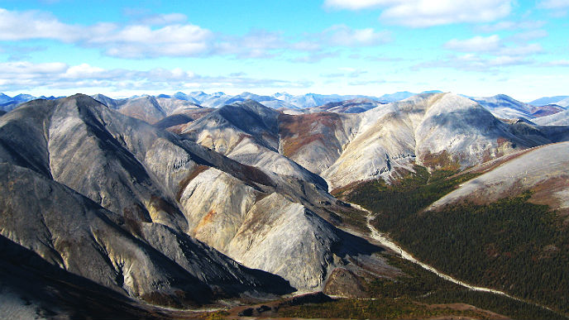

The peaks of the Baird Mountains stretch far into the distance and are so remote that many of them have not been named. Credit: NPS Photo

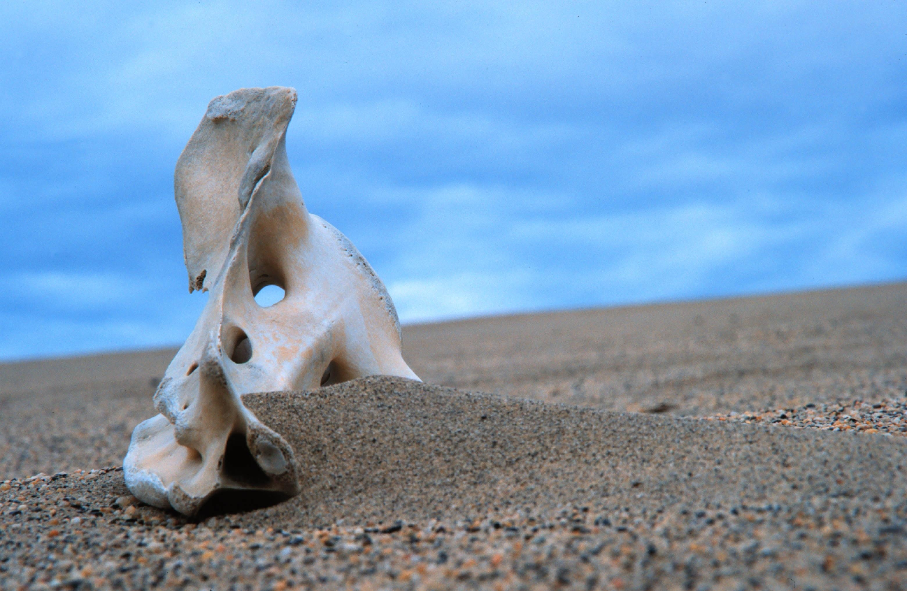

Caribou migrate across the Great Kobuk Sand Dunes, heading north in the summer and south in the fall. Some survive and some don't, which is a reality of life Credit: NPS Photo

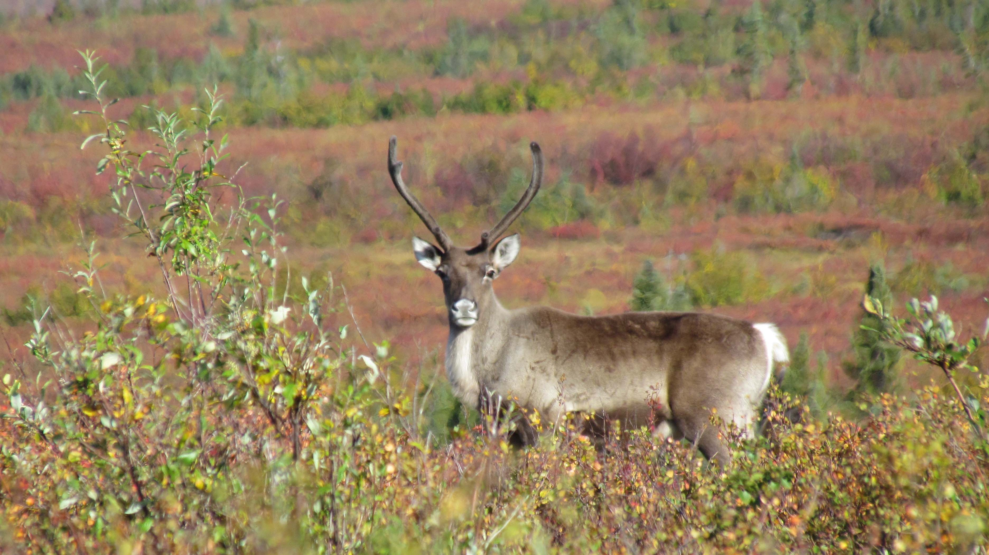

A single caribou of the 240,000+ strong Western Arctic herd on its fall migration south across Kobuk Valley National Park. Credit: NPS Photo

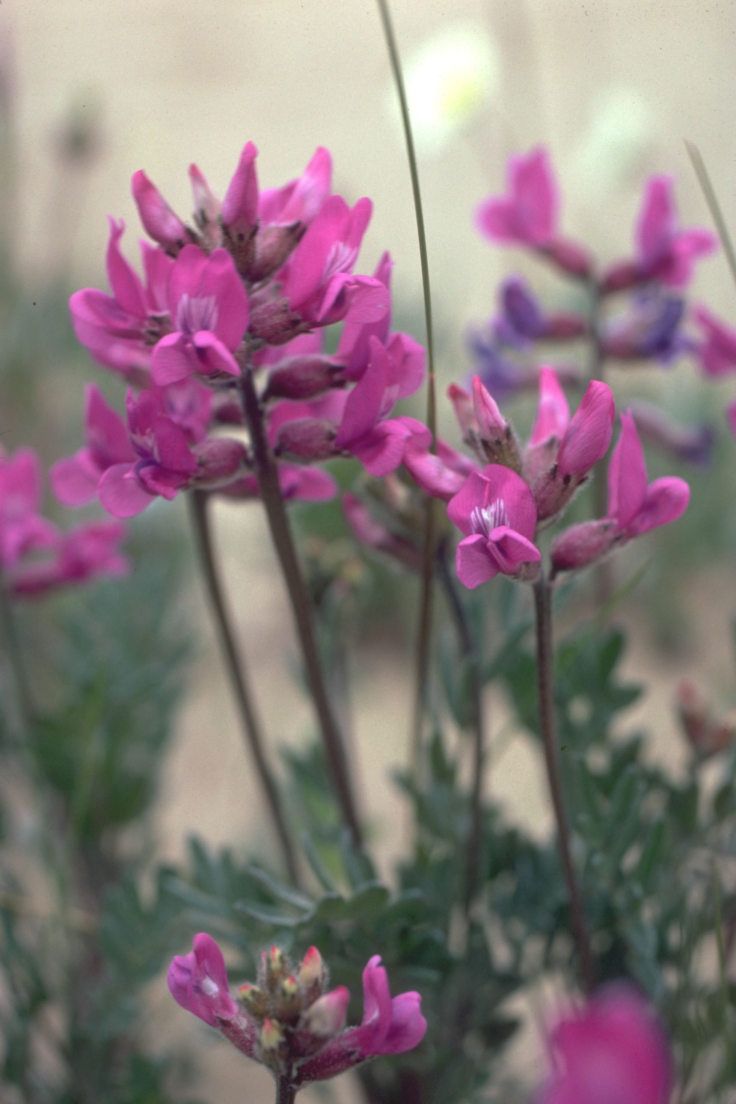

Oxytropis kobukensis (Kobuk Locoweed) is a member of the pea family and adds a splash of pink to the sand dunes. The blossoms have that typical pea/ bean flower shape that many gardeners know. Credit: NPS Photo

## Operating Hours

The Northwest Arctic Heritage Center is the visitor center for Kobuk Valley National Park. Since there are no roads in to Kobuk Valley, the visitor center is located in Kotzebue, AK. From Kotzebue, visitors will charter an air taxi to transport them into the actual national park which is open 24/7 every day of the year.

## Contact Information

### Address

171 3rd Ave  
AK  
99752

### Website

https://www.nps.gov/kova/index.htm

# Isle Royale National Park

## Description

Explore a rugged, isolated island, far from the sights and sounds of civilization. Surrounded by Lake Superior, Isle Royale offers adventures for backpackers, hikers, boaters, kayakers, canoeists and scuba divers. Here, amid stunning scenic beauty, you'll find opportunities for reflection and discovery, and make memories that last a lifetime.

## Weather

Isle Royale National Park is a remote island wilderness in the middle of Lake Superior. Weather influences traveling to and from the island, as well as your trip once you arrive. For the most up-to-date weather information, call (906) 482-0984 or email isro_parkinfo@nps.gov prior to your trip.

## Activities

* Arts and Culture
* Fishing
* Front-Country Hiking
* Guided Tours
* Hiking
* Kayaking

## Images

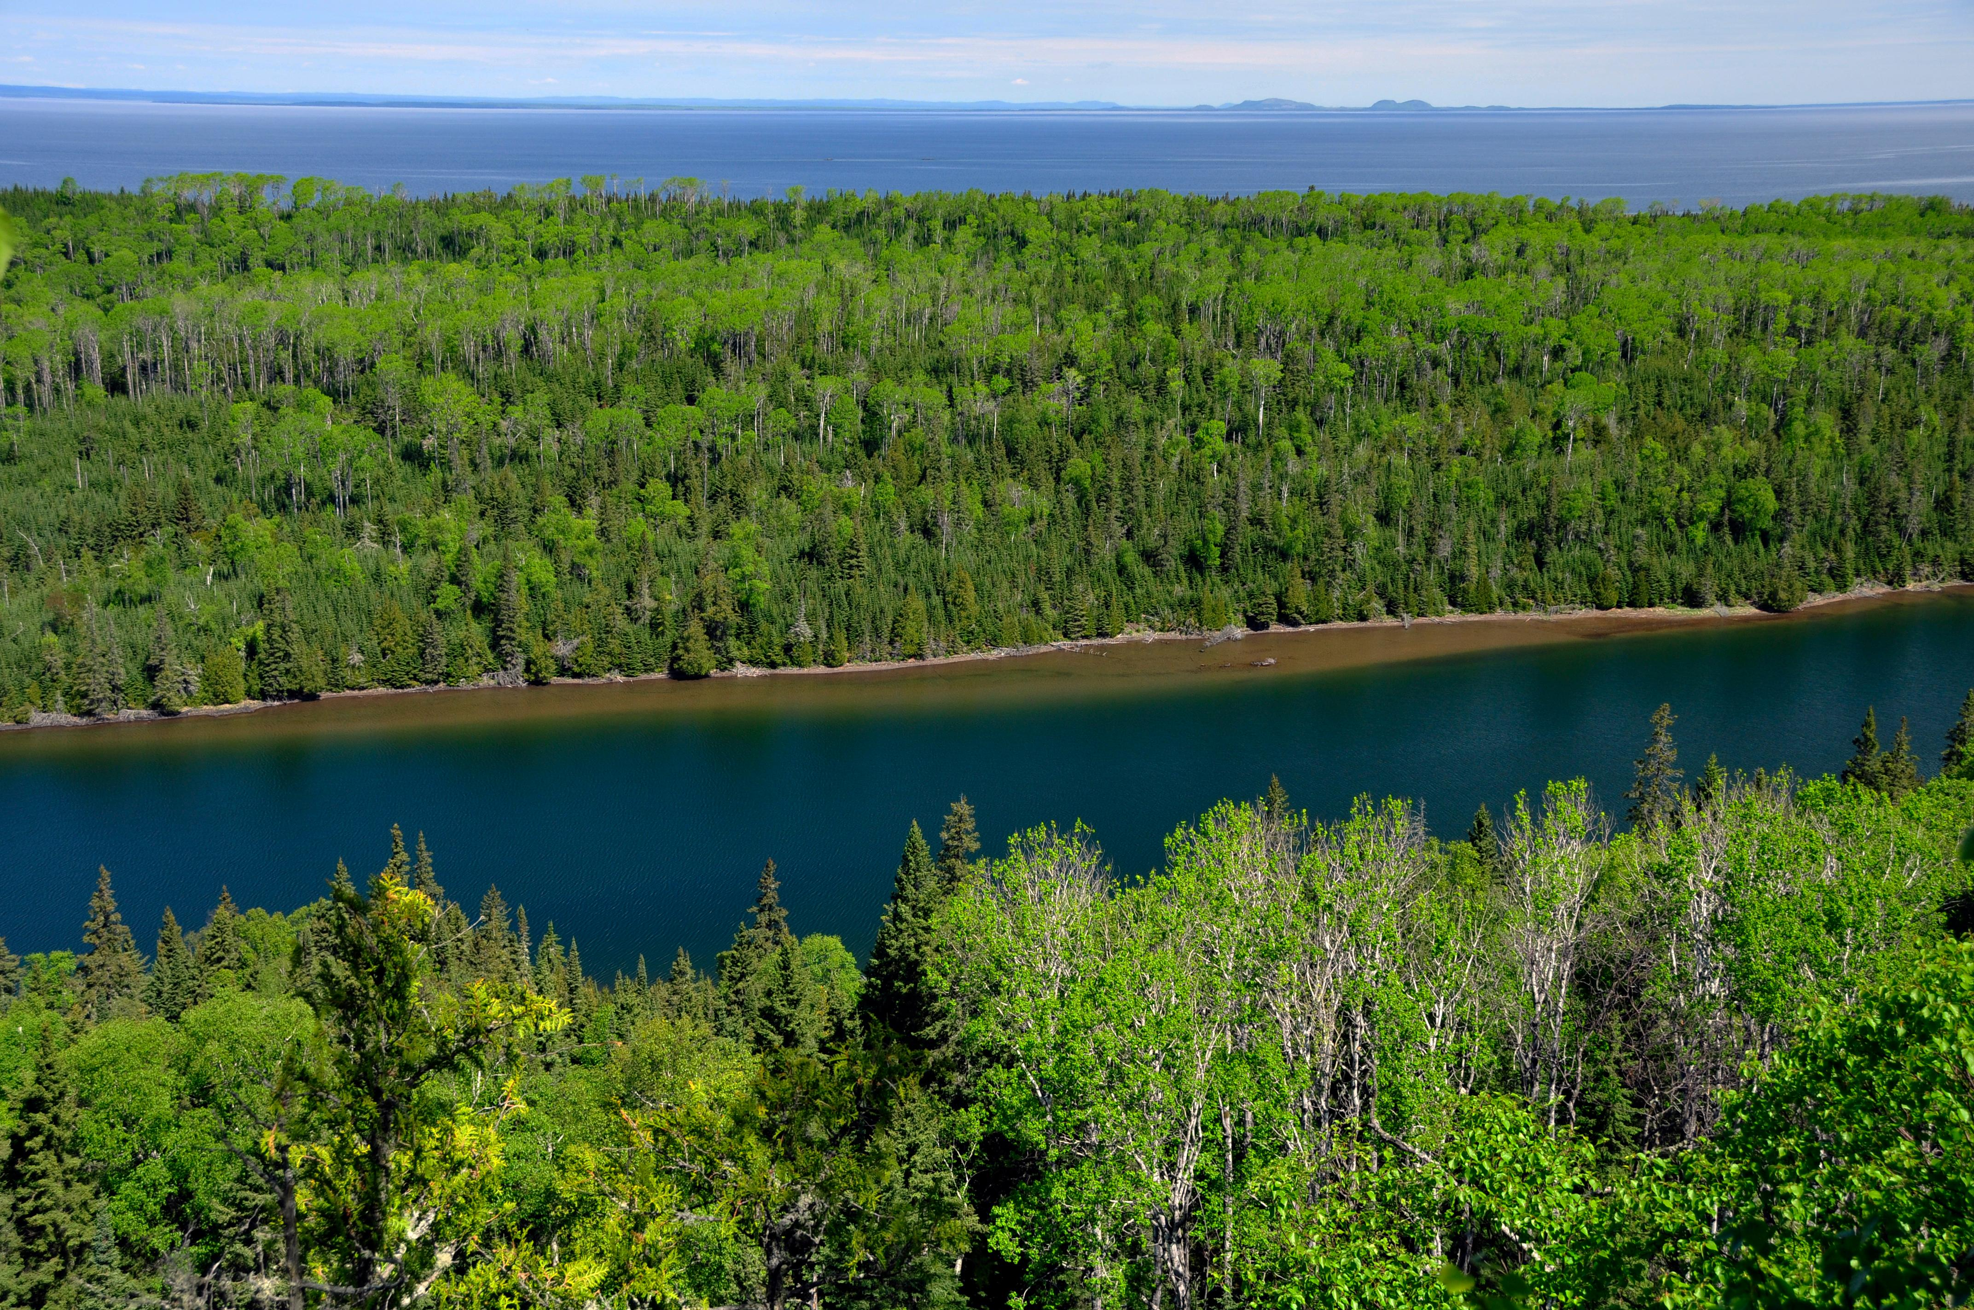

Isle Royale, located in the northwestern corner of Lake Superior, offers views of the Canadian shoreline. Credit: NPS / Paul Brown

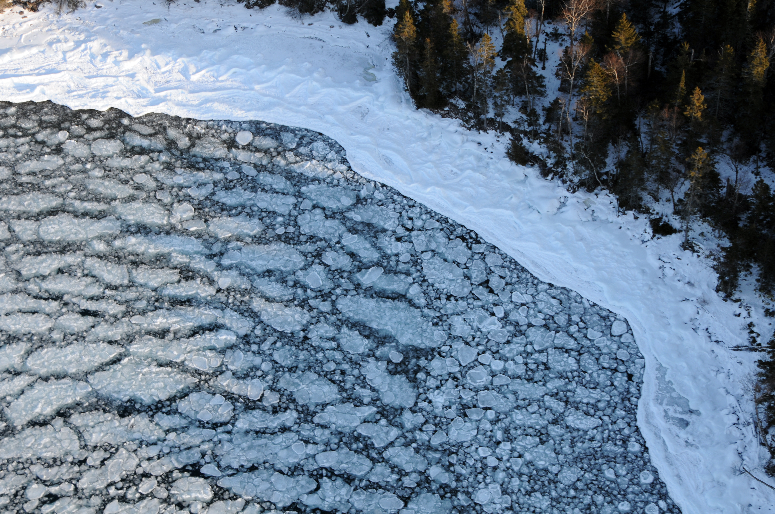

Isle Royale National Park is closed in winter, with the exception of a few visiting researchers. Credit: NPS Photo / Paul Brown

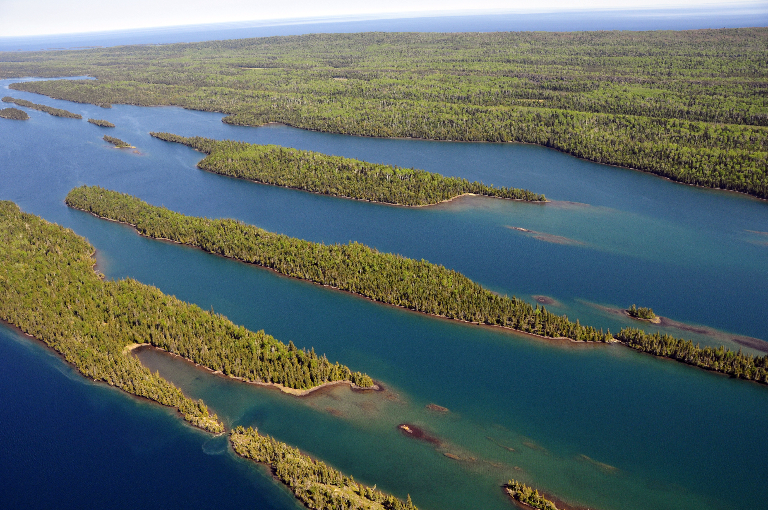

Isle Royale is also called Minong, which means "the good place" by the Grand Portage Band of Lake Superior Chippewa. Minong is a part of the ancestral lands of the Anishinaabe/Ojibwe peoples who have cared for these lands from time immemorial. Credit: NPS Photo / Paul Brown

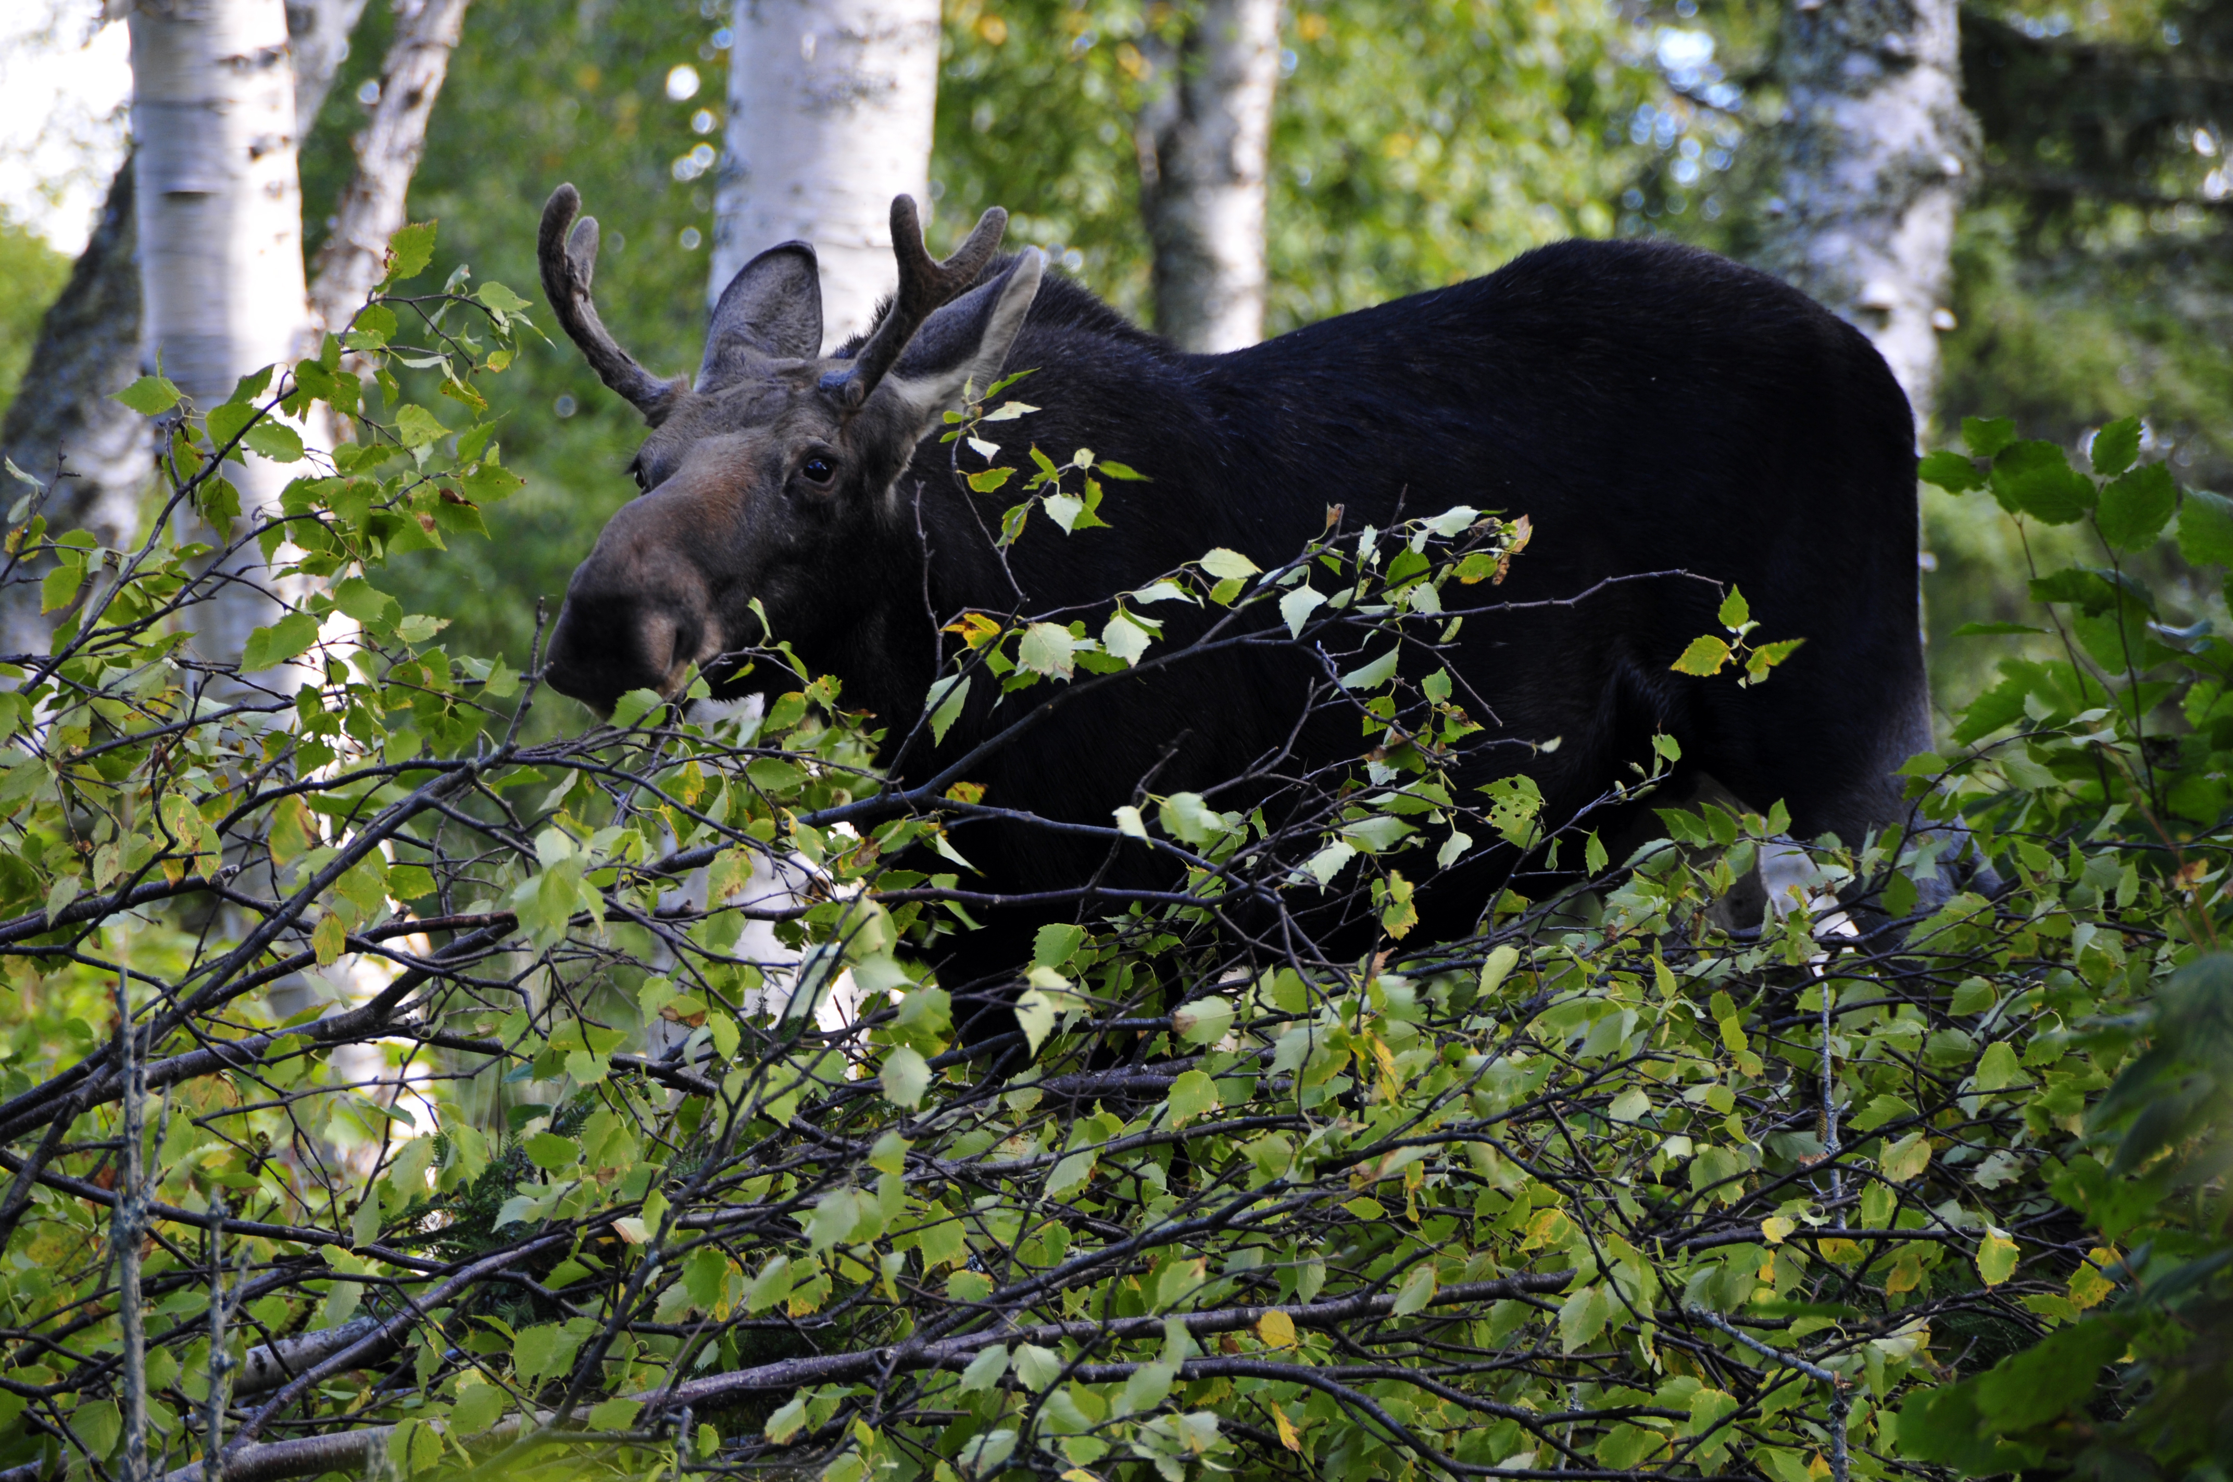

Moose are one of the few mammal species who have journeyed to the island. Credit: NPS Photo / Paul Brown

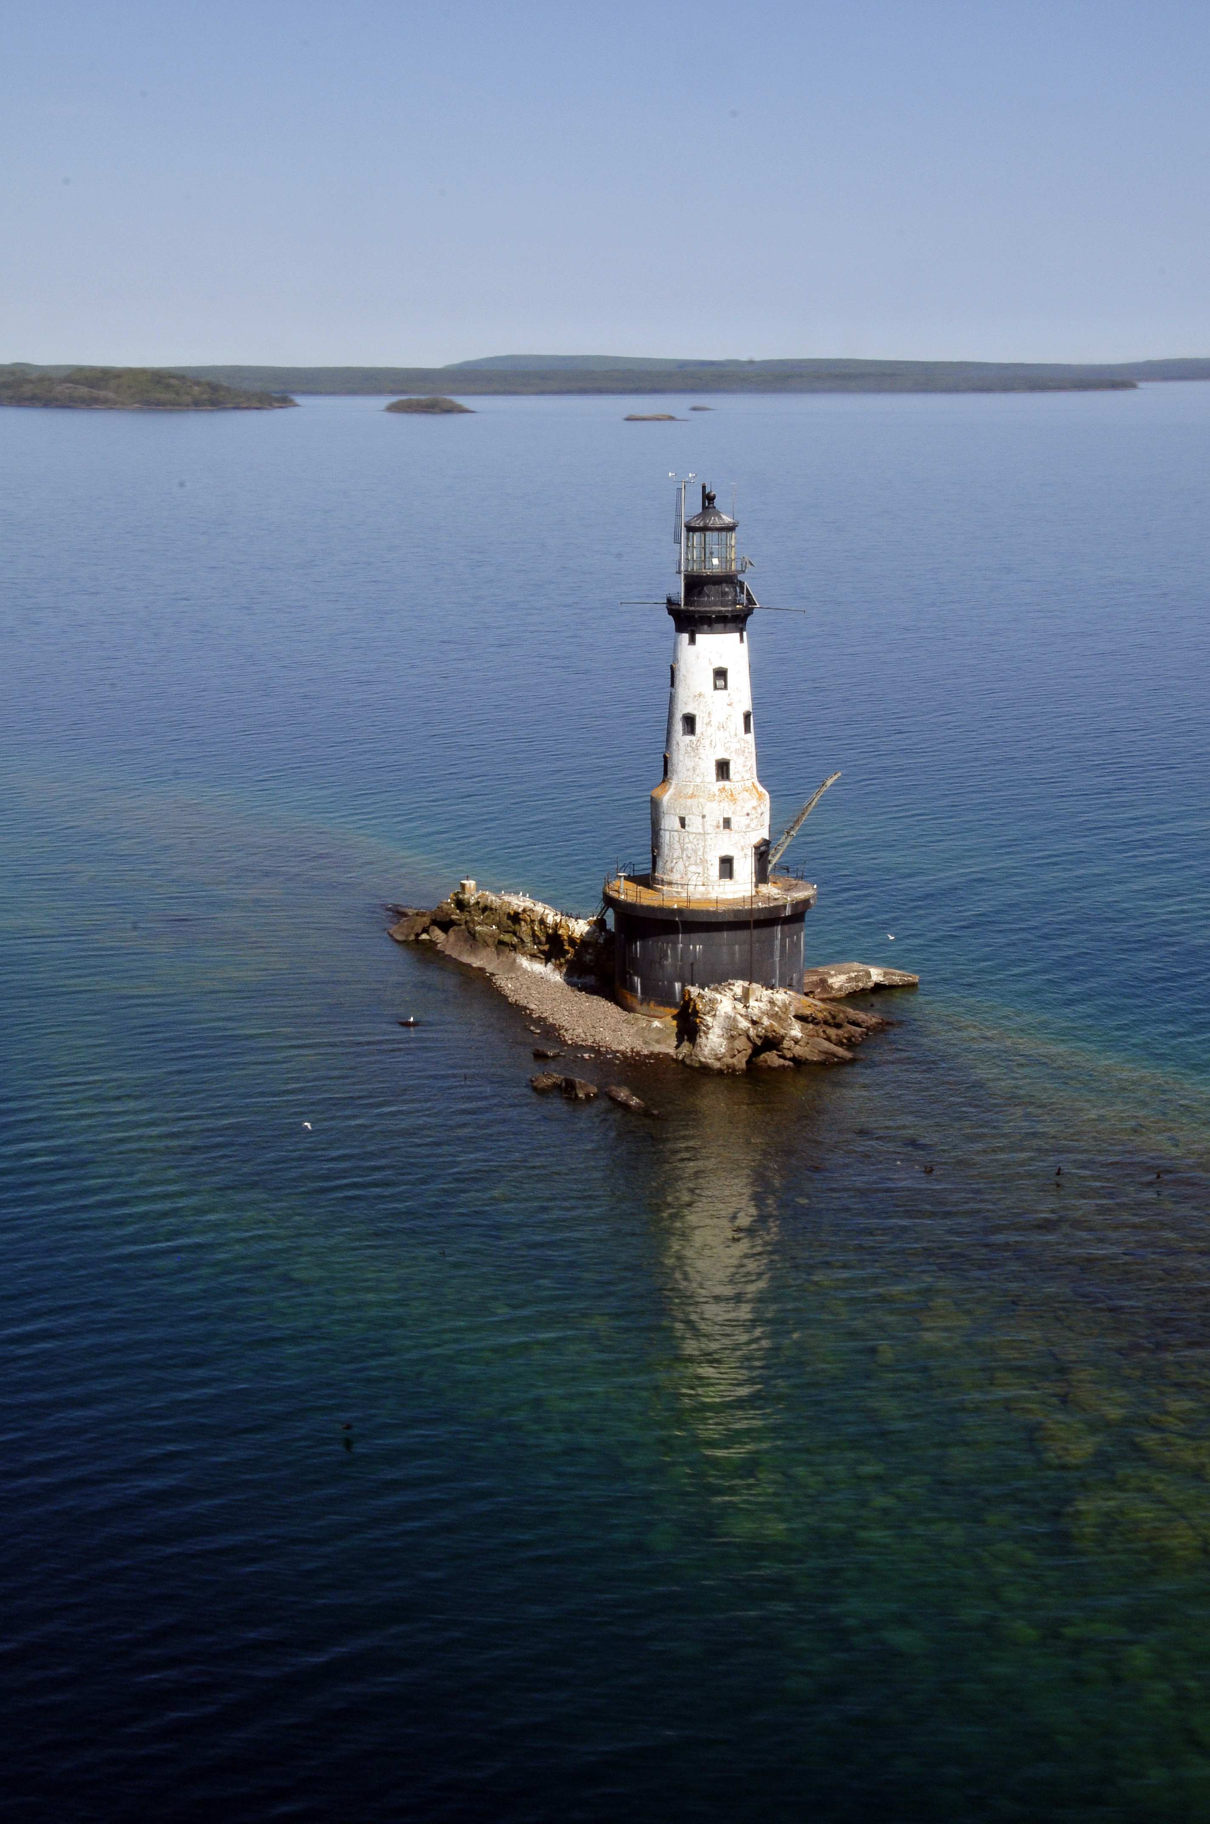

Rock of Ages is one of four lighthouses at Isle Royale National Park. Credit: NPS Photo / Paul Brown

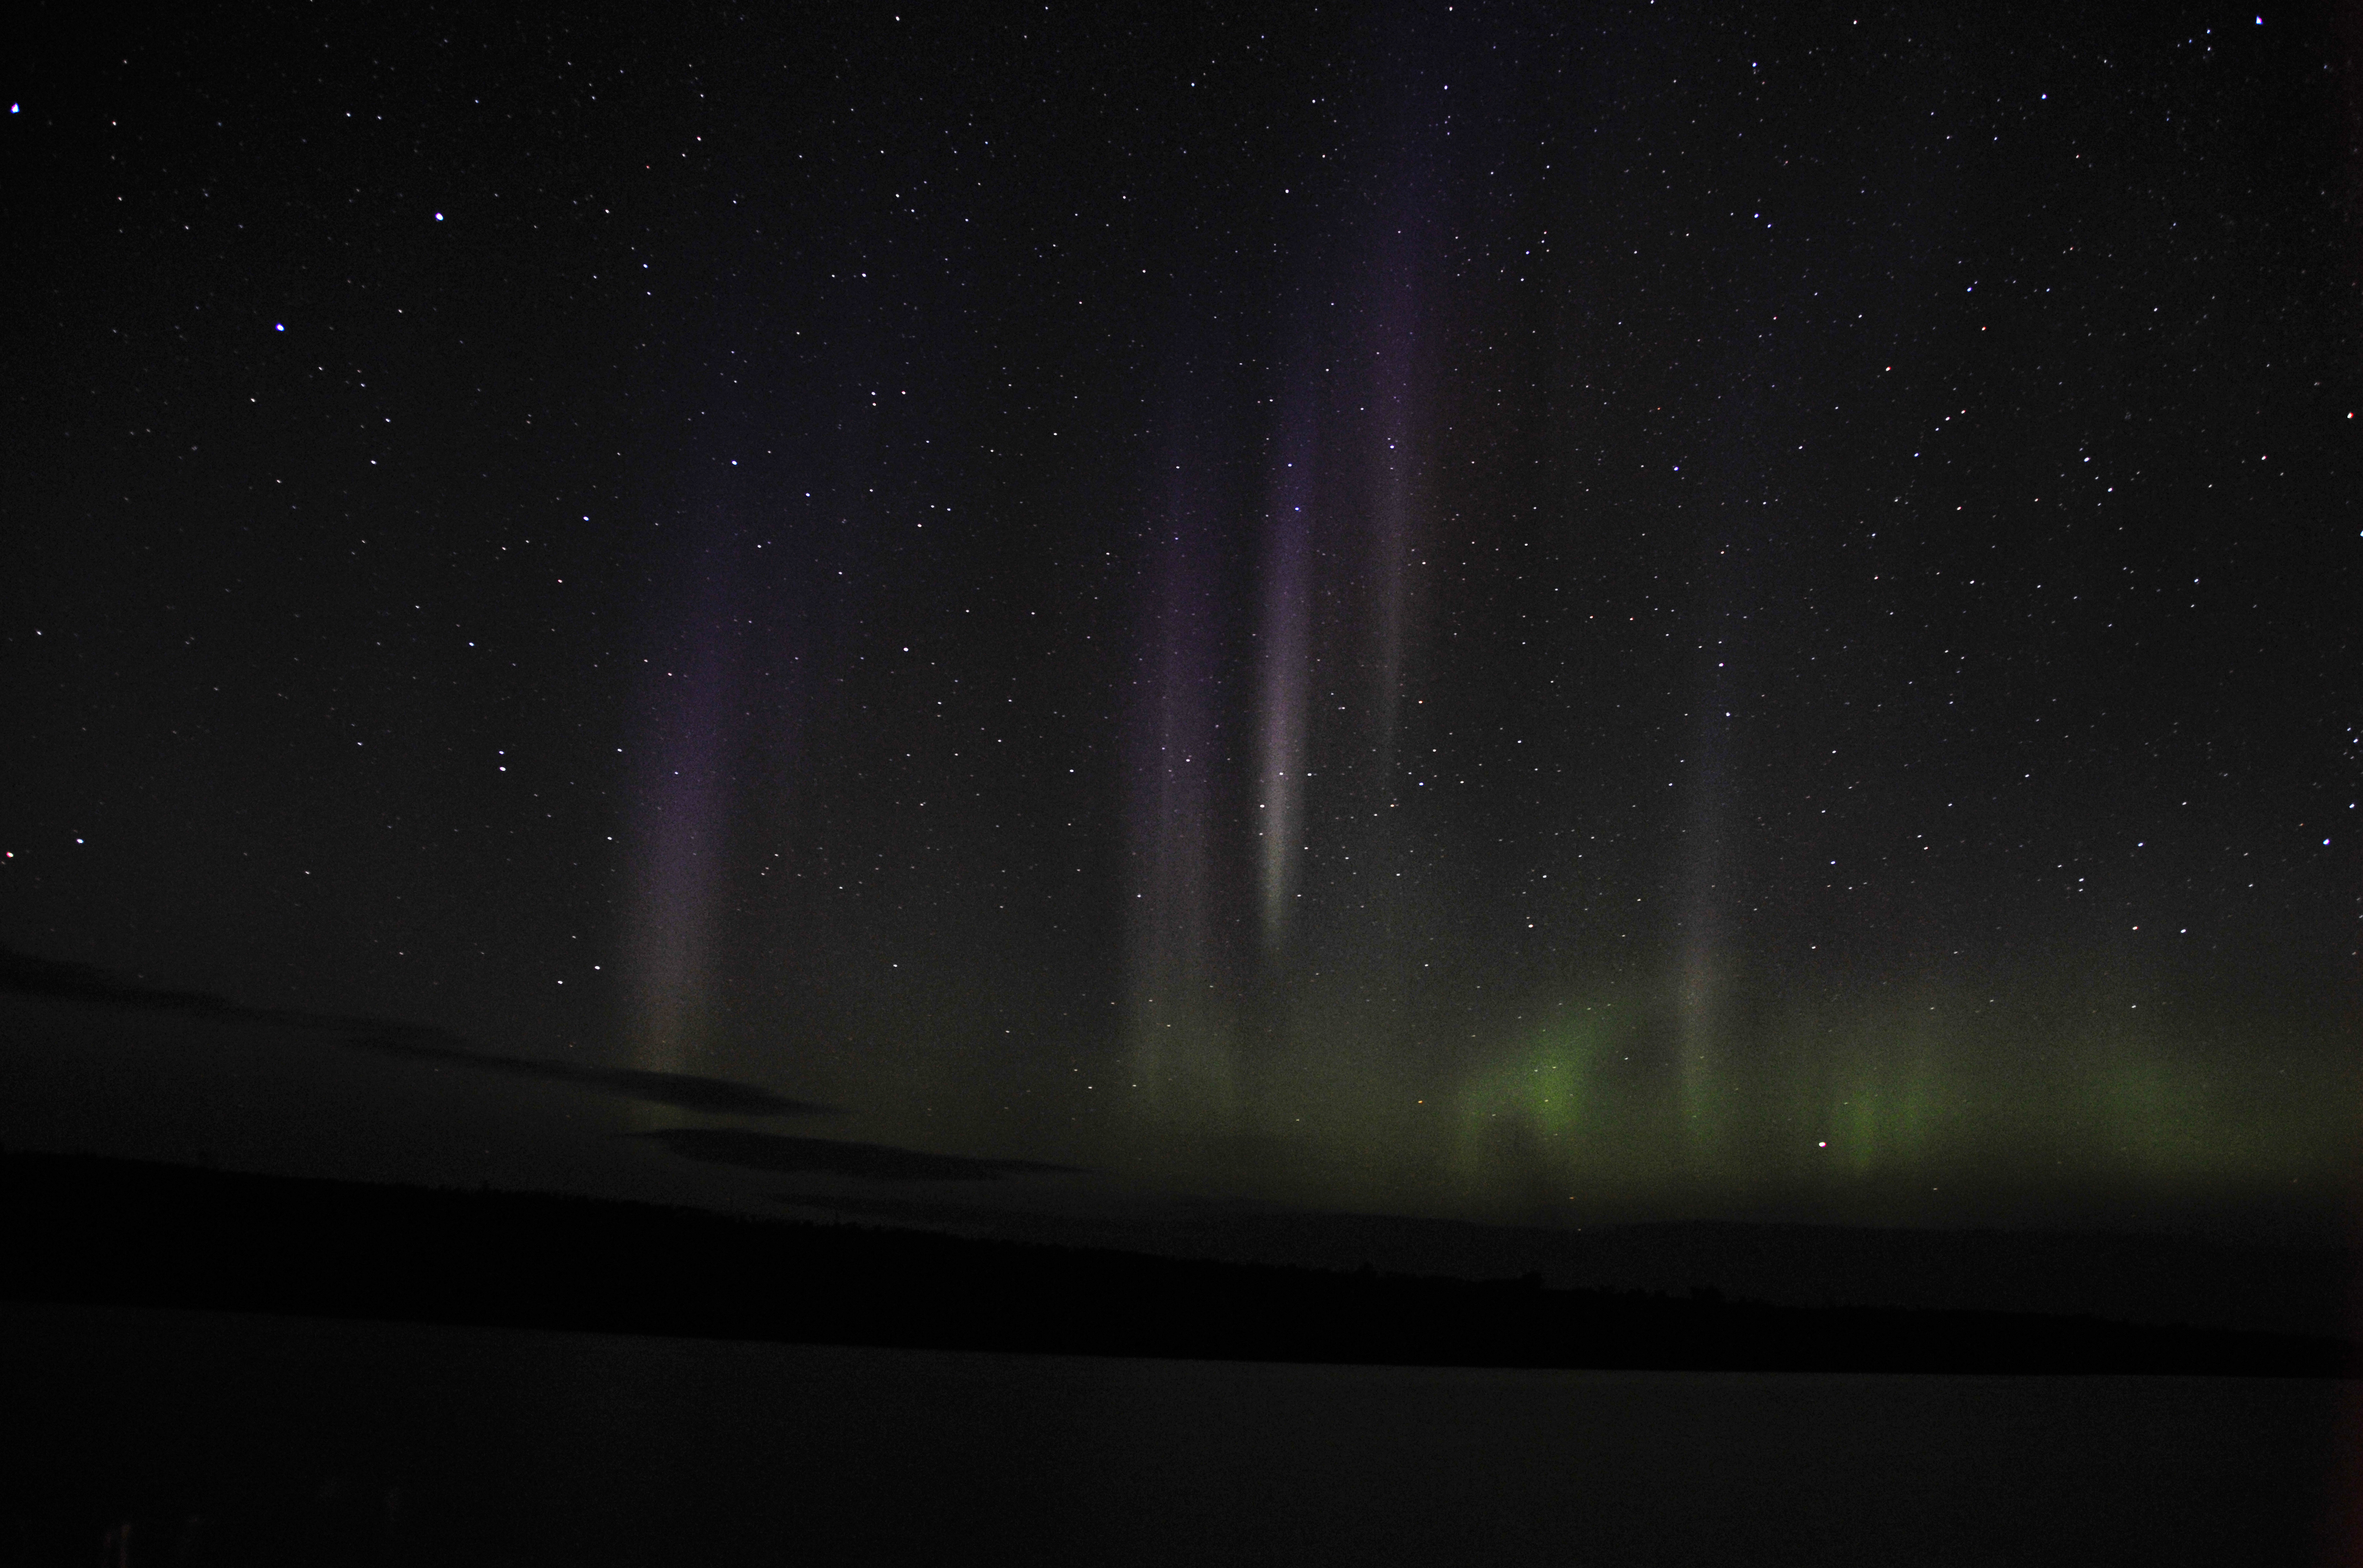

Isle Royale National Park's dark skies make it an excellent location to enjoy nighttime phenomenon, like the Aurora Borealis. Credit: NPS Photo / Paul Brown

## Operating Hours

Isle Royale National Park is open annually from April 16 to October 31. Transportation services are offered from May to September. The island and its surrounding islands are closed to all visitors from November 1 to April 15 due to extreme winter weather conditions and for the safety and protection of visitors. This closure extends 4.5 miles out into Lake Superior from the island. Park headquarters during the winter is in Houghton, Michigan. Summer headquarters is located at Mott Island on Isle Royale.

## Contact Information

### Address

800 East Lakeshore Drive  
MI  
49931

### Website

https://www.nps.gov/isro/index.htm